PUBLIC OFFERING STATEMENT
FOR
JUNIPER RIDGE SUBDIVISION HOMEOWNER'S ASSOCIATION

Date:

Agent/Seller
Buyer Name:

Address/Lot #:

Phone No./Email:

ACKNOWLEDGED RECEIPT, REVIEW AND AGREEMENT TO PROCEED TO CLOSE OF ESCROW:
Dated:

(Print Name)

TABLE OF CONTENTS

PUBLIC OFFERING STATEMENT 1
EXHIBIT A: DECLARATION OF CC&R’s 12
Article 1: Definitions 14
Article 2: Property Subject to this Declaration 16
Article 3: Ownership and Easements 17
Article 4: Lots and Homes 20
Article 5: Common Area 29
Article 6: Architectural Review Committee 31
Article 7: Homeowner’s Association 33
Article 8: Declarant’s Rights 34
Article 9: Declarant’s Special Rights 35
Article 10: Funds and Assessments 35
Article 11: Insurance 40
Article 12: General Provisions 40
EXHIBIT B: MAP OF PROPERTY 45
EXHIBIT C: ARTICLES OF INCORPORATION 47
EXHIBIT D: ASSOCIATION BYLAWS 49
Article 1: Definitions 50
Article 2: Membership 50
Article 3: Meetings and Voting 51
Article 4: Directors: Managements 54
Article 5: Officers 61
Article 6: Assessments, Records and Reports 62
Article 7: Insurance 65
Article 8: General Provisions 67
Article 9: Amendments To Bylaws 67
EXHIBIT E: CONSTRUCTION RULES & REGULATIONS 69
JUNIPER RIDGE SUBDIVISION RULES AND REGULATIONS DURING HOME CONSTRUCTION 70
EXHIBIT #1: LANDSCAPE & RETAINING WALL SPECIFICATIONS 73
EXHIBIT #2: CEDAR FENCING 77
EXHIBIT #3: FINAL LANDSCAPE PLAN 79
EXHIBIT #4: CONCRETE DETAILS 80
EXHIBIT F: ASSOCIATION BUDGET 81
EXHIBIT G: RESERVE STUDY 83

RIGHT TO CANCEL
YOU ARE ENTITLED TO RECEIVE A COPY OF THIS PUBLIC OFFERING STATEMENT AND ALL MATERIAL AMENDMENTS TO THIS PUBLIC OFFERING STATEMENT BEFORE CONVEYANCE OF YOUR UNIT. UNDER RCW 64.90.635, YOU HAVE THE RIGHT TO CANCEL YOUR CONTRACT FOR THE PURCHASE OF YOUR UNIT WITHIN SEVEN (7) DAYS AFTER FIRST RECEIVING THIS PUBLIC OFFERING STATEMENT. IF THIS PUBLIC OFFERING STATEMENT IS FIRST PROVIDED TO YOU MORE THAN SEVEN (7) DAYS BEFORE YOU SIGN YOUR CONTRACT FOR THE PURCHASE OF YOUR UNIT, YOU HAVE NO RIGHT TO CANCEL YOUR CONTRACT. IF THIS PUBLIC OFFERING STATEMENT IS FIRST PROVIDED TO YOU SEVEN (7) DAYS OR LESS BEFORE YOU SIGN YOUR CONTRACT FOR THE PURCHASE OF YOUR UNIT, YOU HAVE THE RIGHT TO CANCEL, BEFORE CONVEYANCE OF THE UNIT, THE EXECUTED CONTRACT BY DELIVERING, NO LATER THAN THE SEVENTH (7th) DAY AFTER FIRST RECEIVING THIS PUBLIC OFFERING STATEMENT, A NOTICE OF CANCELLATION PURSUANT TO THE THIRD PARAGRAPH OF THIS RIGHT TO CANCEL NOTICE. IF THIS PUBLIC OFFERING STATEMENT IS FIRST PROVIDED TO YOU LESS THAN SEVEN (7) DAYS BEFORE THE CLOSING DATE FOR THE CONVEYANCE OF YOUR UNIT, YOU MAY, BEFORE CONVEYANCE OF YOUR UNIT TO YOU, EXTEND THE CLOSING DATE TO A DATE NOT MORE THAN SEVEN (7) DAYS AFTER YOU FIRST RECEIVED THIS PUBLIC OFFERING STATEMENT, SO THAT YOU MAY HAVE SEVEN (7) DAYS TO CANCEL YOUR CONTRACT FOR THE PURCHASE OF YOUR UNIT.

YOU HAVE NO RIGHT TO CANCEL YOUR CONTRACT UPON RECEIPT OF AN AMENDMENT TO THIS PUBLIC OFFERING STATEMENT; HOWEVER, THIS DOES NOT ELIMINATE ANY RIGHT TO RESCIND YOUR CONTRACT, DUE TO THE DISCLOSURE OF THE INFORMATION IN THE AMENDMENT, THAT IS OTHERWISE AVAILABLE TO YOU UNDER GENERALLY APPLICABLE CONTRACT LAW.

IF YOU ELECT TO CANCEL YOUR CONTRACT PURSUANT TO THIS NOTICE, YOU MAY DO SO BY HAND-DELIVERING NOTICE OF CANCELLATION, OR BY MAILING NOTICE OF CANCELLATION BY PREPAID UNITED STATES MAIL, TO THE SELLER AT THE ADDRESS SET FORTH IN PARAGRAPH A OF THIS PUBLIC OFFERING STATEMENT OR AT THE ADDRESS OF THE SELLER'S REGISTERED AGENT FOR SERVICE OF PROCESS. THE DATE OF SUCH NOTICE IS THE DATE OF RECEIPT, IF HAND-DELIVERED, OR THE DATE OF DEPOSIT IN THE UNITED STATES MAIL, IF MAILED. CANCELLATION IS WITHOUT PENALTY, AND ALL PAYMENTS MADE TO THE SELLER BY YOU BEFORE CANCELLATION MUST BE REFUNDED PROMPTLY.
OTHER DOCUMENTS CREATING BINDING LEGAL OBLIGATIONS
THIS PUBLIC OFFERING STATEMENT IS A SUMMARY OF SOME OF THE SIGNIFICANT ASPECTS OF PURCHASING A UNIT IN THIS COMMON INTEREST COMMUNITY. THE GOVERNING DOCUMENTS AND THE PURCHASE AGREEMENT ARE COMPLEX, CONTAIN OTHER IMPORTANT INFORMATION, AND CREATE BINDING LEGAL OBLIGATIONS. YOU SHOULD CONSIDER SEEKING THE ASSISTANCE OF LEGAL COUNSEL.
OTHER REPRESENTATIONS
YOU MAY NOT RELY ON ANY STATEMENT, PROMISE, MODEL, DEPICTION, OR DESCRIPTION UNLESS IT IS (1) CONTAINED IN THE PUBLIC OFFERING STATEMENT DELIVERED TO YOU, OR (2) MADE IN WRITING SIGNED BY THE DECLARANT OR SELLING AGENT OR THE DECLARANT'S SELLING AGENT IDENTIFIED IN THE PUBLIC OFFERING STATEMENT. A STATEMENT OF OPINION, OR A RECOMMENDATION OF THE REAL ESTATE, ITS QUALITY, OR ITS VALUE, DOES NOT CREATE A WARRANTY, AND A STATEMENT, PROMISE, MODEL, DEPICTION, OR DESCRIPTION DOES NOT CREATE A WARRANTY IF IT DISCLOSES THAT IT IS ONLY PROPOSED, IS NOT REPRESENTATIVE, OR IS SUBJECT TO CHANGE.
MODEL UNITS
MODEL UNITS AND/OR LOTS ARE INTENDED TO PROVIDE YOU WITH A GENERAL IDEA OF WHAT A FINISHED UNIT MIGHT LOOK LIKE. UNITS BEING OFFERED FOR SALE MAY VARY FROM THE MODEL UNIT IN TERMS OF FLOOR PLAN, FIXTURES, FINISHES, AND EQUIPMENT. YOU ARE ADVISED TO OBTAIN SPECIFIC INFORMATION ABOUT THE UNIT YOU ARE CONSIDERING PURCHASING.

RESERVE STUDY
THE ASSOCIATION IS REQUIRED TO HAVE A CURRENT RESERVE STUDY. ANY RESERVE STUDY SHOULD BE REVIEWED CAREFULLY. IT MAY NOT INCLUDE ALL RESERVE COMPONENTS THAT WILL REQUIRE MAJOR MAINTENANCE, REPAIR, OR REPLACEMENT IN FUTURE YEARS, AND MAY NOT INCLUDE REGULAR CONTRIBUTIONS TO A RESERVE ACCOUNT FOR THE COST OF SUCH MAINTENANCE, REPAIR, OR REPLACEMENT. YOU MAY ENCOUNTER CERTAIN RISKS, INCLUDING BEING REQUIRED TO PAY AS A SPECIAL ASSESSMENT YOUR SHARE OF EXPENSES FOR THE COST OF MAJOR MAINTENANCE, REPAIR, OR REPLACEMENT OF A RESERVE COMPONENT, AS A RESULT OF THE FAILURE TO: (1) HAVE A CURRENT RESERVE STUDY OR FULLY FUNDED RESERVES, (2) INCLUDE A COMPONENT IN A RESERVE STUDY, OR (3) PROVIDE ANY OR SUFFICIENT CONTRIBUTIONS TO A RESERVE ACCOUNT FOR A COMPONENT.
DEPOSITS AND PAYMENTS
ONLY EARNEST MONEY AND RESERVATION DEPOSITS ARE REQUIRED TO BE PLACED IN AN ESCROW OR TRUST ACCOUNT. ANY OTHER PAYMENTS YOU MAKE TO THE SELLER OF A UNIT ARE AT RISK AND MAY BE LOST IF THE SELLER DEFAULTS.
CONSTRUCTION DEFECT CLAIMS
CHAPTER 64.50 RCW CONTAINS IMPORTANT REQUIREMENTS YOU MUST FOLLOW BEFORE YOU MAY FILE A LAWSUIT FOR DEFECTIVE CONSTRUCTION AGAINST THE SELLER OR BUILDER OF YOUR HOME. FORTY-FIVE (45) DAYS BEFORE YOU FILE YOUR LAWSUIT, YOU MUST DELIVER TO THE SELLER OR BUILDER A WRITTEN NOTICE OF ANY CONSTRUCTION CONDITIONS YOU ALLEGE ARE DEFECTIVE AND PROVIDE YOUR SELLER OR BUILDER THE OPPORTUNITY TO MAKE AN OFFER TO REPAIR OR PAY FOR THE DEFECTS. YOU ARE NOT OBLIGATED TO ACCEPT ANY OFFER MADE BY THE BUILDER OR SELLER. THERE ARE STRICT DEADLINES AND PROCEDURES UNDER STATE LAW, AND FAILURE TO FOLLOW THEM MAY AFFECT YOUR ABILITY TO FILE A LAWSUIT.
ASSOCIATION INSURANCE
THE EXTENT TO WHICH ASSOCIATION INSURANCE PROVIDES COVERAGE FOR THE BENEFIT OF UNIT OWNERS (INCLUDING FURNISHINGS, FIXTURES, AND EQUIPMENT IN A UNIT) IS DETERMINED BY THE PROVISIONS OF THE DECLARATION AND THE ASSOCIATION'S INSURANCE POLICY, WHICH MAY BE MODIFIED FROM TIME TO TIME. YOU AND YOUR PERSONAL INSURANCE AGENT SHOULD READ THE DECLARATION AND THE ASSOCIATION'S POLICY PRIOR TO CLOSING TO DETERMINE WHAT INSURANCE IS REQUIRED OF THE ASSOCIATION AND UNIT OWNERS, UNIT OWNERS' RIGHTS AND DUTIES, WHAT IS AND IS NOT COVERED BY THE ASSOCIATION'S POLICY, AND WHAT ADDITIONAL INSURANCE YOU SHOULD OBTAIN.
QUALIFIED WARRANTY
YOUR UNIT IS NOT QUALIFIED WARRANTY UNDER CHAPTER 64.35 RCW.
SPECIFIC INFORMATION
- NAME AND ADDRESS OF THE DECLARANT. Juniper Ridge, LLC, a Washington Limited Liability Company, 5900 NE 152nd Ave Suite 120, Vancouver, WA 98682.
- NAME AND ADDRESS OF THE MANAGEMENT COMPANY OF THE ASSOCIATION (if any): Currently Declarant managed.

- RELATIONSHIP OF THE MANAGEMENT COMPANY TO THE DECLARANT (if any): Same.

- NAME AND ADDRESS OF THE COMMON INTEREST COMMUNITY: Juniper Ridge Subdivision Homeowner’s Association, 5900 NE 152nd Ave, Suite 120, Vancouver, WA 98682.

- NATURE OF THE COMMON INTEREST COMMUNITY: Subdivision.

- RECENT COMMON INTEREST COMMUNITIES COMPLETED BY THE DECLARANT OR AN AFFILIATE OF THE DECLARANT WITHIN THE PAST FIVE (5) YEARS: None.

- NATURE OF THE INTEREST BEING OFFERED FOR SALE: Fee simple.

- GENERAL DESCRIPTION OF THE COMMON INTEREST COMMUNITY:

1) Park Area in the North, 2) Sitting Area in the South, 3) Storm Pond and Associated Infrastructure not on Privately Owned Lots, 4) Any Fences as stated in the HOA Documents, and any other areas shown on the recorded Plat Map.

- STATUS OF CONSTRUCTION OF THE UNITS AND COMMON ELEMENTS: Upon recording of Plat with Clark County, Washington.

- NUMBER OF EXISTING UNITS IN COMMUNITY: 60

- PRINCIPAL COMMON AMENITIES IN THE COMMUNITY, AND THOSE THAT WILL BE OR MAYBE ADDED TO THE COMMUNITY:

1) Park Area in the North, 2) Sitting Area in the South, 3) Storm Pond and Associated Infrastructure not on Privately Owned Lots, 4) Any Fences as stated in the HOA Documents, and any other areas shown on the recorded Plat Map.

- LIMITED COMMON ELEMENT'S THAT MAY BE ALLOCATED TO THE UNITS OFFERED FOR SALE: None

- RIGHTS OF NON-UNIT OWNERS TO USE ANY OF THE COMMON ELEMENTS: Tenants and guests of Unit Owners, invitees and service people will have access to the common elements.

- REAL PROPERTY NOT IN THE COMMUNITY THAT UNIT OWNERS HAVE A RIGHT TO USE: Trail Easement will be owned and managed by The City of La Center.

- SERVICES PROVIDED BY THE DECLARANT THAT ARE NOT IN THE COMMUNITY BUDGET: None.

- ESTIMATED ASSESSMENT OR PAYMENT, IF ANY, WHICH MUST BE PAID AT CLOSING: $450

- LIENS OR ENCUMBRANCES THAT WILL REMAIN ON THE COMMON ELEMENTS AFTER CLOSING: None.

- EXPRESS CONSTRUCTION WARRANTIES TO BE PROVIDED TO THE BUYER: None.

- AVAILABILITY OF QUALIFIED WARRANTY: None.

- BUILDING ENCLOSURE DESIGN AND INSPECTION: Per RCW 64.50 et seq.

- UNSATISFIED JUDGMENTS OR PENDING SUITS AGAINST THE ASSOCIATION; PENDING SUITS MATERIAL TO THE COMMUNITY OF WHICH THE DECLARANT HAS ACTUAL KNOWLEDGE: None.

- LITIGATION BROUGHT BY AN OWNER’S ASSOCIATION, UNIT OWNER OR GOVERNMENTAL ENTITY AGAINST THE DECLARANT OR ANY AFFILIATE ARISING OUT OF THE CONSTRUCTION, SALE OR ADMINISTRATION OF ANY COMMON INTEREST COMMUNITY WITHIN THE PREVIOUS FIVE (5) YEARS: None.

- RESTRICTIONS ON USE OR OCCUPANCY; RENTAL RESTRICTIONS; RIGHTS OF FIRST REFUSAL; RESALE RESTRICTIONS: See Declaration, Article 4.

- INSURANCE COVERAGE PROVIDED FOR THE BENEFIT OF UNIT OWNERS: Homeowner's Association Insurance to cover common elements and officer/director indemnification.

- CURRENTOR EXPECTED FEES FOR THE USE OF ANY COMMON ELEMENTS OR FACILITIES, OR TO ANY OTHER ASSOCIATION, WHICH ARE NOT INCLUDED IN THE COMMON EXPENSES: None.

- BONDS OR THIRD-PARTY ASSURANCES THAT THE IMPROVEMENTS WILL BE BUILDING: None.

- COOPERATIVE: AVAILABILITY OF TAX PASS-THROUGH: N/A

- COOPERATIVE: EFFECT OF ASSOCIATION'S FAILURE TO PAY TAXES OR SECURED DEBT: N/A

- LEASEHOLD COMMUNITY: INFORMATION ABOUT MASTER LEASE: N/A

- SUMMARY OF' RESERVE STUDY: No Initial Reserve Study.

- COST SHARING ARRANGEMENTS WITH OTHER ASSOCIATIONS OR PERSONS: N/A

- ESTIMATED CURRENT COMMON EXPENSE LIABILITY FOR UNITS BEING SOLD: $450 Annually for HOA fees, preferably through escrow.

- ASSESSMENTS, FEES OR CHARGES KNOWN TO THE DECLARANT AND WHICH MAY CONSTITUTE A LIEN IN FAVOR OF A GOVERNMENTAL AGENCY AGAINST A UNIT OR THE COMMON ELEMENTS IF NOT' PAID: Except for real property taxes, real property assessments, utility liens, and liens related to stormwater maintenance obligations, none.

- PORTIONS OF THE COMMUNITY (OTHER THAN UNITS) THAT A UNIT OWNER MUST MAINTAIN: None.

- RESTRICTIONS ON TIMESHARING: See Declaration, Article 4.

- SPECIAL DECLARANT RIGHTS RESERVED TO THE DECLARANT; TERMINATION DATES; RECORDED TRANSFERS OF SPECIAL DECLARANT RIGHTS: Complete improvements indicated on Map; exercise any Development Right; maintain sales offices, management offices, signs advertising the Lots until Declarant no longer owns a right to create a unit; use easements through the common elements for the purpose of making improvements within the subject development; appoint or remove any officer of the Association or any member of the Board of Directors, during the period of Declarant Control; veto or approve a proposed action of the Board or Association, during any period of Declarant Control; control any construction, design review or aesthetic standards committee or process; attend meetings of the unit owners and, except during an executive session, the Board; and have access to the records of the Association to the same extent as a unit owner. See also Development Rights, Declaration Article 8, 9 & 10.

- LIENS ON REAL ESTATE TO BE CONVEYED TO THE ASSOCIATION: None.

- PHYSICAL HAZARDS KNOWN TO THE DECLARANT THAT ARE NOT READILY ASCERTAINABLE BY THE BUYER: None.

- BUILDING CODE VIOLATION CITATIONS RECEIVED BY THE DECLARANT IN CONNECTION WITH THE COMMUNITY THAT HAVE NOT BEEN CORRECTED: None.

- BUILDINGS OVER FIVE (5) YEARS OLD: None.

- ADDITIONAL INFORMATION OF INTEREST: None.

- AGE-RELATED OCCUPANCY RESTRICTIONS: None.

- MATERIAL DIFFERENCES IN TERMS OF FURNISHINGS, FIXTURES, FINISHES AND EQUIPMENT BETWEEN UNIT RENDERINGS, DEPICTIONS AND ILLUSTRATIONS AND UNITS BEING OFFERED: N/A

- THE FOLLOWING DOCUMENTS ARE A PART OF THIS PUBLIC OFFERING STATEMENT':
Exhibit A — Declaration of Covenants, Conditions & Restrictions
Exhibit B — Map
Exhibit C — Association Articles of Incorporation
Exhibit D — Association Bylaws
Exhibit E — Association Rules & Regulations (reserved) (including Exhibits #1, #2, #3 and #4)
Exhibit F — Association Budget
Exhibit G — Reserve Study (reserved)

Juniper Ridge, LLC
Dated: By:

Its:

[TITLE COMPANY PLEASE INSERT INFORMATION ABOUT: GRANTOR, GRANTEE, LEGAL DESCRIPTION, TAX PARCEL #, REFERENCE #'S]
When Recorded, Return to:
Juniper Ridge, LLC
5900 NE 152nd Ave
Suite 120
Vancouver, WA 98682

DRAFT

DECLARATION OF COVENANTS, CONDITIONS AND RESTRICTIONS FOR JUNIPER RIDGE SUBDIVISION HOMEOWNER’S ASSOCIATION

Grantor:
- TD West LLC, a Washington limited liability company
Grantee:
- Juniper Ridge Subdivision
Legal Description:
- Located in the Northwest ¼ and the Southwest ¼ of the Southwest ¼ of Section 34, Township 5 North, Range 1 East of the Willamette Meridian, in the City of La Center, Clark County, Washington.
- Additional legal on Exhibit A
Assessor’s Property Tax Parcel #: 258945000 & 258944000
Reference Number(s) of Related Documents: Book ____ Page ____ AFN ____

(Note – The Declarant shall have the authority to make changes to the CCR’s).

EXHIBIT A
TO PUBLIC OFFERING STATEMENT
(DECLARATION OF COVENANTS, CONDITIONS & RESTRICTIONS)

DECLARATION OF COVENANTS, CONDITIONS, AND RESTRICTIONS
FOR
JUNIPER RIDGE SUBDIVISION HOMEOWNER'S ASSOCIATION

THIS DECLARATION OF COVENANTS, CONDITIONS AND RESTRICTIONS OF JUNIPER RIDGE SUBDIVISION HOMEOWNER’S ASSOCIATION (“Declaration”) is made on the 14th day of September 2026, by Juniper Ridge, LLC, a Washington Limited Liability Company (“Declarant”).
Recitals
- The Declarant is the owner, or controls, all that certain real property and improvements thereon located in La Center, Washington, referred to as Juniper Ridge Subdivision (also referred to as the "Property"), recorded at Auditor's File No.____________in Book ____, Page______ (the "Plat").

- Declarant intends to develop the Property as a planned community known as "JUNIPER RIDGE SUBDIVISION" which is a plat community as defined in RCW 64.90.010(37). And, Declarant desires to impose these mutually beneficial covenants, conditions, restrictions, easements, assessments and liens on the Property under a comprehensive general plan of improvement and development for the benefit of all of the Owners, the Lots and Common Area, within "JUNIPER RIDGE SUBDIVISION" ("CCRs" and/or "Declaration").

- To the extent there is a conflict between this Declaration and any mandatory or nonwaivable provision of RCW 64.90, the provisions of RCW 64.90 shall control. However, to the extent there is a conflict between this Declaration and a provision of RCW 64.90 that is either not mandatory or that can be waived or altered, the provisions of this Declaration shall control.

- Declarant will create a Homeowner's Association, to which will be delegated and assigned the powers and authority to own, maintain and administer the Association, the Common Area, and facilities, and administer and enforce the covenants, conditions, and restrictions of this Declaration, and collect and disburse the assessments and charges hereinafter created.

NOW THEREFORE, the Declarant declares that the Property shall be held, transferred, sold, conveyed and occupied subject to the following covenants, conditions, restrictions, easements, charges and liens, or as noted herein, which shall run with the land and shall be binding upon all parties having or acquiring any right, title or interest in the Property or any part thereof and shall inure to the benefit of the Association and for the benefit of each Lot Owner.

Article 1
Definitions
  - "Architectural Review Committee" or "ARC" shall mean the Declarant until turnover and thereafter shall refer to the Board of Directors unless the Board has appointed a separate body to carry out the functions described in Article 6 of the Declaration in which case "ARC' shall refer to this body.
  - "Articles" shall mean the Articles of Incorporation for the non-profit corporation, Juniper Ridge Subdivision Homeowner's Association, or such similar name approved by and filed with the Washington Secretary of State, Corporations Division.
  - "Association" and/or "HOA" shall mean and refer to “Juniper Ridge Subdivision Homeowner's Association," its successors and assigns.
  - "Board of Directors" and/or "Board" shall mean the Board of Directors of the Juniper Ridge Subdivision Homeowner's Association.
  - "Builder" or "Approved Builder" shall mean a Builder who has purchased one or more Lots from the Declarant, or the Declarant's assignee or successor, and is authorized to construct a Home on said Lots (if any). Said Builder shares in the special Declarant rights related to construction and marketing. Once assessments have commenced, any Lot owned by a Builder will pay assessments to the Association from the date the escrow closes between the Declarant and said Builder.
  - "Building Structure" shall mean a building that is comprised of one or more contiguous Homes constructed and located on a Lot, as a primary residential unit along with nonresidential structures such as garage, outbuilding, and/or other similar structures located on the Lots, whether attached to or detached from the Building Structure.
  - "Bylaws" shall mean and refer to the Bylaws of the Association, which shall be properly adopted.
  - "Common Area(s)" shall mean and refer to any areas of land shown on the recorded Plat of the Property, including any improvements thereon, which are intended to be devoted to the common use and enjoyment of all the members of the Association, and areas outlined herein as the maintenance responsibility of the Association, unless provided otherwise in this Declaration. In reference to RCW 64.90.210, and as evidenced by the Plat, no interior element of any living unit in Juniper Ridge Subdivision is considered a common element or area.
  - "Juniper Ridge Subdivision" and/or "Subdivision" shall mean the real property described within the Plat of Juniper Ridge Subdivision, including without limitation Lots 1 through 60, any annexations of additional lands to Juniper Ridge Subdivision and all Common Area included within the Plat of Juniper Ridge Subdivision.
  - "Declarant" shall mean and refer to Juniper Ridge, LLC, its successors or assigns, or any successor or assign to any of their interests in the development of the Property. "Declarant" shall not refer to any other subsequent purchaser of a Lot.
  - "Declaration" shall mean the covenants, conditions, restrictions, and all other provisions set forth in this Declaration of Covenants, Conditions and Restrictions for Juniper Ridge Subdivision, as may be amended.
  - "General Common Expenses" shall mean those expenditures made or liabilities incurred by the Association, including reserves. Such definition should also apply to the term, "Common Expenses" as used in this Declaration.
  - "General Plan of Development" shall mean the Declarant's general plan of development of the Property as approved by appropriate governmental agencies, as may be amended.
  - "Home" and/or "Dwelling Unit" and/or "Unit" shall mean and refer to any portion of a structure situated on a Lot designed and intended for use and occupancy as a residence by a single family or household.
  - "Limited Common Expenses" Not applicable.
  - "Lot" shall mean and refer to any plot of land used for a Home, as indicated upon the recorded subdivision map of Juniper Ridge Subdivision.
  - "Lot Easement Area" shall mean and refer to those portions of any Lot subject to any easement benefiting the Association. The term “Lot Easement Area" shall not refer to any portions of any Lot encumbered by an easement to any other party, including without limitation, any governmental entity.
  - "Members" shall mean and refer to the Owners of Lots in the Juniper Ridge Subdivision and who are members of the Juniper Ridge Subdivision Homeowner's Association.
  - "Occupant" shall mean and refer to the occupant of a Home who shall be the Owner, lessee or any other person authorized by the Owner to occupy the premises.
  - "Owner" shall mean and refer to the record Owner, including Declarant, whether one or more persons or entities, of the fee simple title to any Lot or a purchaser in possession under a land sale contract. The foregoing does not include persons or entities that hold an interest in any Lot merely as security for the performance of an obligation.
3
  - "Plat" shall mean and refer to the recorded Plat(s) of Juniper Ridge Subdivision as may be amended.
  - “Property” shall mean and refer to all real property described within the Plat of Juniper Ridge Subdivision, including without limitation Lots 1-60, as well as any future annexations of additional property (if applicable). Property includes the Common Areas, and all improvements located on the real property, as may be brought within the jurisdiction of the Association and be made subject to this Declaration.
  - "Rules and Regulations" shall mean and refer to the documents containing rules and regulations and policies adopted by the Board or the Architectural Review Committee ("ARC"), and as may be from time to time amended by the Board and/or ARC.
  - "Turnover Meeting" shall be the meeting called by the Declarant to turn over control of the Association to the Owners as required by RCW 64.90.415.

Article 2
Property Subject to this Declaration

  - The real property which is and shall be held, transferred, sold, conveyed and occupied subject to this Declaration is located in La Center, Washington, in that certain Plat map entitled “Juniper Ridge Subdivision" filed in the Plat records of Clark County, Washington, more particularly described as consisting of Lots 1 through 60, including the commons areas.
Common Expenses. Pursuant to RCW 64.90.235, the allocation of units for Common Expenses and voting is 1/60th. The formula used to allocate units is pro rata based on the total number of units in Juniper Ridge Subdivision.
- Limited Common Expenses. Not applicable.
  - At any time during the initial term of this Declaration, the Declarant may, at its sole option, annex additional property into the Association to be subject to the terms hereof to the same extent as if originally included herein and subject to such other terms, covenants, conditions, easements and restrictions as may be imposed thereon by Declarant. Provided, however, Declarant shall have no obligation of any kind to annex any additional land to the Property.
  - Consent or Joinder Not Required. No consent or joinder of any Owner, or other party, except the Declarant and the record owner of the land being annexed shall be necessary to effect any annexation made pursuant to this Section.

  - Declaration of Annexation. Annexation shall be evidenced by a written Declaration of Annexation executed by the Declarant, or (in the case of an annexation by action of members) by the Board and the Owners of the property being annexed, setting forth the legal description of the property being annexed and any additional covenants, conditions and restrictions to be applied to such annexed property. Notwithstanding any provision apparently to the contrary, a declaration with respect to any annexed property may:

    - Establish such new land classifications and types of Lots and such limitations, uses, restrictions, covenants and conditions with respect thereto as Declarant may deem to be appropriate for the development of the annexed property;

    - With respect to existing land classifications, establish additional or different limitations, uses, restrictions, covenants and conditions with respect thereto as Declarant may deem to be appropriate for the development of such annexed property; and/or

    - Contain provisions necessary or appropriate to comply with any condition, requirement, or imposition of any governmental or regulatory authority.

  - Voting Rights: Allocation of Assessments. Upon annexation, additional Lots so annexed shall be entitled to voting rights and shall be responsible for payment of assessments as required for that fiscal year. At the beginning of the next fiscal year, assessments for the general common areas shall be apportioned equally based upon the total number of Lots, following such annexation.

    - No Duty to Annex. Nothing herein contained shall establish any duty or obligation on the part of the Declarant to annex into the Association, and no owner of property excluded from the Association shall have any right to have such property annexed thereto. Declarant is under no obligation to build Homes on any or all of the Lots contained in the original Plat.

Article 3
Ownership and Easements

  - Non-Severability. The Common Areas shall be maintained, managed and governed by the Association. The interest of each Owner in the use and benefit of the Common Areas shall be appurtenant to the Lot owned by the Owner. No Lot shall be conveyed by the Owner separately from the interest in the Common Area, subject to the provisions of Section 3.3. Any conveyance of any Lot shall automatically transfer the right to use the Common Areas without the necessity of express reference in the instrument of conveyance. There shall be no judicial partition of the Common Area. Each Owner, whether by deed, gift, devise or operation of law, for his/her own benefit and for the benefit of all other Owners, specifically waives and abandons all rights, interests and causes of action for judicial partition of any interest in the Common Areas and does further agree that no action for judicial partition shall be instituted, prosecuted or reduced to judgment. The ownership interest in the Common Areas and Lots described in this Article are subject to the easements granted and reserved in this Declaration for drainage, and any needed maintenance support. Each of the easements reserved or granted herein shall be deemed to be established upon the recordation of this Declaration and shall forever be deemed to be covenants running with the land for the use and benefit of the Owners and their Lots and shall be superior to all other encumbrances applied against or in favor of any portion of Juniper Ridge Subdivision. Any damage caused to the Common Areas by a Lot Owner may be repaired by the Association, at the cost of such Lot Owner.
  - Ownership of Lots. Title to each Lot in Juniper Ridge Subdivision shall be conveyed in fee to an Owner. If more than one person and/or entity owns an undivided interest in the same Lot, such person and/or entities shall constitute one (I) Owner for purposes of membership in the Association.
  - Ownership of Common Areas. Title to Common Areas, including without limitation, easements, rights of ways, fences, landscaping, drainage areas, irrigation equipment, pipes & equipment, storm water system^{l}, utilities, communications lines, play equipment, benches, tables, or other equipment or amenities that serve the Common Areas (if any), are being conveyed to the Association at the time of recordation of the original Plat. The Board may convey title to any present or future Common Area, to a City, County or other Government agency. The Association, with the approval of 80% of the Association membership, may sell, convey or mortgage the Common Area. As per the Plat for Juniper Ridge Subdivision, the common area Tracts shall be maintained by the Association.
  - Easements. Individual deeds to Lots may, but shall not be required to, set forth the easements specified in this Article.
    - Easements on Plat. The Lots and Common Areas are subject to all easements and rights-of-way shown, or noted, on the Plat of Juniper Ridge Subdivision.
    - Easements for Common Area. Every Owner shall have a non-exclusive right and easement of use and enjoyment in and to the Common Area, which shall be appurtenant to and shall pass with the title to every Lot.
    - Easements Reserved by Declarant. So long as Declarant owns any Lot, Declarant reserves an easement over, under and across the Common Areas in order to carry out sales activities necessary or convenient for the sale of Lots. In addition, Declarant hereby reserves to itself, and for its successors and assigns, a perpetual easement and right-of-way for access over, upon and across the Common Areas for construction, maintenance, utilities, communication lines, ^{l}(which is subject to the Declaration of Easements, Covenants, Conditions, & Restrictions for Maintenance of Stormwater Facilities, recorded concurrently herewith) drainage, and ingress and egress for the benefit of the Lots or other property owned by Declarant. Declarant, for itself and its successors and assigns, hereby retains a right and easement of ingress and egress over, in, upon, under and across the Common Area and the right to store materials thereon and to make such other use thereof as may be reasonably necessary or incident to the construction of the improvements on the Property or other real property owned by Declarant in such a way as to not unreasonably interfere with the occupancy, use, enjoyment or access to an Owner's Lot by that Owner or his/her family, tenants, guests or invitees.
    - Shared Driveway Easement. Declarant hereby grants and conveys to the Owners of Lots 21–24 a non-exclusive, perpetual easement for ingress, egress, and utilities over Shared Driveway B, and to the Owners of Lots 29–31 a non-exclusive, perpetual easement for ingress, egress, and utilities over Shared Driveway A, as more particularly shown on the Plat (collectively, the “Shared Driveways”). Each such easement shall be appurtenant to and run with the benefited Lots. The Owners of Lots 21–24 shall equally share the cost of all maintenance and repair of Shared Driveway B. The Owners of Lots 29–31 shall equally share the cost of all maintenance and repair of Shared Driveway A.
    - Additional Easements. Notwithstanding anything expressed or implied to the contrary, this Declaration shall be subject to all easements granted by Declarant for the installation and maintenance of utilities, pathways, border fencing, access roads and drainage facilities necessary for the development of Juniper Ridge Subdivision. No structure, planting or other material shall be placed or permitted to remain within any Easement Area which may damage or interfere with the installation or maintenance of utilities, or which may change the direction of flow of drainage channels in the easements, or which may obstruct or retard the flow or water through drainage channels in the easements. The Easement Area of each Lot and all improvements thereon shall be maintained continuously by the Owner of the Lot, except for those improvements for which a public authority, utility company or the Association is responsible.
    - Association's Easements. There are hereby reserved to the Association and its duly authorized agents and representatives such easements as are necessary to perform the duties and obligations of the Association set forth in this Declaration, the Bylaws and Articles, for the maintenance of the drainage and needed support for the structures, and any exterior maintenance.
    - Easement to Governmental Entities. There is hereby reserved and granted a non-exclusive easement over the Common Area to all governmental and quasi-government entities, agencies, utilities, and their agents for the purposes of performing their duties within Juniper Ridge Subdivision. However, where applicable, the Association may be subject to compensation for the taking or use of such easement rights.
    - Landscaping. The Association reserves an easement for any landscape maintenance, upkeep and replacement, as well as utilities pertaining to landscaping or maintenance for any buffer landscaping and any entry monument, even if outside of designated Common Areas (if applicable). Further, all Common Areas are subject to landscape maintenance easements over their entirety in favor of the Association. All Lot Owners will be responsible to plant and maintain the trees shown on their lot on the final plat, as well as maintaining landscaped lots.
    - Private and Public Storm Water and Sewer Easements. Private and Public Storm Water and Sewer Easements exist along the property lines of Lots identified on the Plat of Juniper Ridge Subdivision which can be accessed by the Juniper Ridge HOA and The City of La Center as needed for maintenance or repairs.
    - Storm Water Facility. In conjunction with the recording of the final Plat for the Subdivision, the Declarant is, or will be, constructing a storm water facility. The Association shall maintain any and all storm water facility, whether constructed prior to the recording of the Final Plat upon the Property or thereafter. The Association will be responsible for the two (2) year maintenance inspection and replacement/cleaning of storm filtration cartridges and vaults if needed to be maintained by the Declarant, or whatever is required by governmental authorities.
    - Maintenance Easement. An easement is hereby reserved in favor of the Association and its successors, assigns, contractors, agents and employees over, under, and across each Lot, the Common Areas, landscaped areas, and other areas of the Property necessary or appropriate for the purposes of accomplishing the maintenance, repair, and replacement of improvements, should such maintenance, repair and replacement be deemed necessary in order to maintain the standards of the Association and of the ARC.
    - Maintenance Obligations/Owner Restrictions. Except as specifically noted in this document, the Owner, at his/her expense, shall maintain, repair and replace the improvements and utility installations in any Lot Easement Area and shall hold the Association harmless from any such costs.
    - Private Street Maintenance. (Not applicable.)
    - Public Utility Easements. Public Utility Easements and street light locations are reserved, as defined on the Plat(s) of Juniper Ridge Subdivision. No building, structure, tree or other obstruction shall be placed or located on or in a Public Utility Easement. A private meter may be installed for street lighting, and the Association shall be responsible for all power and streetlight maintenance (if applicable).
    - Retaining Walls. Not to exceed 3 feet 10 inches (46 inches) from the base, (Maximum 3’ or 36” above Finished Grade) completely adhering to the manufacturer’s recommendations unless approved by the ARC. All walls must meet manufacturer specifications and may require Geogrid.
    - Fences & Signage. Permanent and continuous fencing and permanent signage (if applicable) may be installed, owned, and maintained by the Association along the outer parameter of Tract "A", “B”, “D”, “E” and “F”, as set forth on the Plat, or as decided by the Board. Additionally, the Association may maintain all fencing facing the public streets W 14th Street and W G Court, if the Lot Owners do not take proper care. The Association's maintenance will be limited to painting or staining the exterior street-facing surfaces, but any replacement costs for boards for the fences shall be borne by the respective Lot Owner. Fencing installed upon any Lot within the Subdivision shall meet the requirements described herein (see Exhibit #2), and approved by ARC, except fencing installed around the Stormwater Pond and/or other common areas, which shall be chain link type fencing.
    - Building Envelope. Each Lot has a defined area within which the Home is to be built. Any building must be approved by both the permitting jurisdiction and the ARC, or their designated representative for ARC reviews.

Article 4
Lots and Homes

  - Residential Use. NO Lot shall be further subdivided or partitioned to create more than one (1) legal lot. Lots shall be used for residential purposes only. Except with the consent of the Board, no trade, craft, business, profession, commercial or similar activity of any kind shall be conducted on any Lot, nor shall any goods, equipment, vehicles, materials or supplies used in connection with any trade, service or business be kept or stored on any Lot. Nothing in this paragraph shall be deemed to prohibit the following:
    - Commercial Activities of Individual Residences. The right of the Owner of a Lot to maintain his/her professional or personal library, keep his/her personal business or professional records or accounts, handle his/her personal business or professional telephone calls or confer with business or professional associates, clients or customers, in his/her residence, so long as such activity is not observable outside of the residence, does not significantly increase parking or vehicular traffic, or is in violation of applicable local government ordinances. The mere parking on a Lot or in the street, of a vehicle bearing the name of a business shall not, in and of itself, constitute a violation of this provision. The Board shall not approve commercial activities otherwise prohibited by this paragraph unless the Board determines that only normal residential activities would be observable outside of the residence and that the activities would not be in violation of applicable local government ordinances.
Neither the Association or the Board shall be held responsible for any loss of wages, income or computer connectivity if telephone, computer or internet service is interrupted by the Association, an Association vendor, or utility, or the management agent related to any activity on a Lot.
    - Declarant Construction Activities. Nothing in this Section shall be deemed to prohibit (a) activities related to the rental or sale of a Lot, or (b) the right of Declarant or any contractor or homebuilder to construct improvements on any Lot, to store construction materials and equipment on such Lots in the normal course of construction, and to use any Lot as a sales or rental office or model.
  - Construction. Except for construction performed by or contracted for by Declarant, no construction, reconstruction or exterior alterations shall occur on any Lot, unless the approval of the ARC is first obtained pursuant to Article 6. Consideration such as building placement, shape, size, color, design, height, solar access, or material may be taken into account by the ARC in determining whether or not to consent to any proposed work. Such work includes, but is not limited to Homes, accessory buildings/structures, shops, storage shelters, swimming pools, spas, hard landscaping, greenhouses, patios, fencing, basketball hoops or remodeling (as applicable). The intent of this covenant is to ensure quality of workmanship and material, harmony of external design with the existing and planned structures as to location and visual compatibility and finish grade elevations. Original construction designs, materials and product specifications by the Association may vary from any or all specified in this document. All construction performed by or contracted for by Declarant, shall be presumed to have met these minimum requirements or have been granted a variance thereto.
  - Building Restrictions. The following restrictions are minimum standards applicable to all Lots. All Buildings and Construction will also have to meet The City of La Center standards in the MDR-16 zoning and be properly permitted.
    - Mobile Homes. Mobile, manufactured, module, temporary or pole-barn type structures used as the Home will not be permitted on any Lot within Juniper Ridge Subdivision;
    - Single Family Homes.
      - Minimum square footage: 1,199 sq. ft. living area, unless otherwise approved by ARC;
      - Garage: required, carports are not permitted, unless otherwise approved by ARC;
      - Exterior Finishes: must be Hardie plank type siding on street facing exterior, masonry or stone veneer are acceptable with Hardie and wood siding acceptable on the remainder of the structure, vinyl or plastic siding are not permitted, unless otherwise approved per ARC;
      - Exterior Paint: stained or painted with semi-transparent or solid stains, painted in natural hues, unless otherwise approved by ARC;
      - Roof: 30 year black or grey asphalt shingled roofing (No metal roofs other than standing seam approved by the ARC), minimum pitch shall be 6:12 except porch roofs which may be as shallow as 3:12, unless otherwise approved by ARC;
      - Landscaping walls: shall meet standards shown on Exhibit #1 unless otherwise approved by ARC;
      - Building Setbacks: 5 feet from the property line on each side of a detached home, and 5 feet from the property line for an end unit of an attached home. Does not apply to zero lot line attached homes.
      - Fencing: shall meet standards shown on Exhibit #2, unless otherwise approved by ARC;
      - Driveways: concrete from garage to curb; no dirt, gravel or asphalt driveways permitted (see Exhibit #4 for specifics on sizes), unless otherwise approved by ARC;
      - Decks: stained, painted, metal rail or Trex composite, in natural shades consistent with exterior color of the home, unless otherwise approved by ARC; and
      - Landscaping and Irrigation: required in front, including street side in corner lots and planter strips unless otherwise approved by ARC;
      - Completion: all construction of structure and front yard landscaping shall be complete (with certificate of occupancy) within one (1) year of commencement. At minimum if house construction has not begun, any required retaining walls, fences, trees, and sidewalks must be completed within 18 Months of original Lot purchase date.
    - Single Family Attached. In addition to the requirements of LCMC § 18.140.040, a single-family attached proposal shall meet the requirements of this section. Where a conflict exists between general and specific standards the director shall apply the more specific standard.
      - Land divisions shall be reviewed according to Chapter 18.205 or 18.210 LCMC and Chapter 58.17 RCW. Building permits for attached developments may only be approved where fully consistent with the approved land division.
      - Notations on the Plat and/or covenants running with the land, approved by the city attorney, shall guarantee that required side setbacks shall be kept perpetually free of obstructions.
      - Single-family attached housing shall not be permitted in buildings of greater than six units.
      - No portion of a unit may occupy space above or below any other unit.
      - Landscaping. Single-family attached development projects may satisfy the minimum landscaping requirement by:
        - Providing 200 square feet of enclosed private outdoor living area per bedroom for each individual dwelling unit, to be located in the rear or side yard of each individual lot; or
        - Providing 200 square feet of common indoor or outdoor recreation area per bedroom for each individual dwelling unit.
        - Landscaping and Irrigation is required in front, including street side in corner lots unless otherwise approved by ARC along with required trees.
        - Front yard landscaping shall be complete (with certificate of occupancy) within one (1) year of commencement.
  - Mechanical Equipment and Solar Panels. Placement of any mechanical equipment, window mounted air conditions, heat pump, condenser or generator shall not be visible in the front elevation of any Lot and be screened from street view. Use of solar heating systems is permissible, pursuant to RCW 64.90.510, and provided the solar panels or collectors are integrated into the home's design and consistent with the overall appearance of Juniper Ridge Subdivision and are subject to approval by the ARC. A six (6) foot cleared area around all fire hydrants shall be maintained by the Lot Owner.
  - Rental of Homes. An Owner shall be entitled to rent or lease his/her entire residence, subject to the following:
    - Written Rental Agreements. A written rental or lease agreement is required, specifying that: (i) the tenant shall be subject to all provisions of the Declaration, Bylaws and Rules and Regulations, and (ii) failure to comply with any provision of the Declaration, Bylaws and Rules and Regulations shall constitute a default under the rental agreement;
    - Minimum Rental Period. The period of the rental or lease is not less than 30 days;
    - Tenant Must Be Given Documents. The Owner gives each tenant a copy of the Declaration, Bylaws and Rules and Regulations; and
    - Owner Responsibility. Owner shall be responsible for any violations by tenants and shall be solely responsible for either correcting or eliminating such violations or getting tenant to do the same. Owner shall be responsible to notify the Association of any rental of Homes within 10 days of occupancy by any renter, tenant or such occupant.
  - Animals. No farm animals, livestock or poultry of any kind shall be raised, bred, kept or permitted within any Lot other than a reasonable number of domestic household pets which are not kept, bred or raised for commercial purposes and which are reasonably controlled so as not to be a nuisance. Any inconvenience, damage or unpleasantness caused by such pets, including noise, shall be the responsibility of the respective Owners to remediate immediately. No dogs shall be permitted to roam the Property unattended, and all dogs shall be kept on a leash while outside a Lot. An Owner may be required to remove a pet from the Property upon the receipt of the third notice in writing from the Association Board of violation of any rule, regulation or restriction. A "reasonable number of domestic household pets" and the definition of "domestic household pets" shall be subject to rules adopted and approved by the Board in its sole discretion. Animal enclosures, including dog runs and dog houses, shall not be located in any yard area of a Lot which is visible to the public.
  - Nuisance. No unlawful, harmful or offensive activities shall be carried on upon any Lot or Common Area, nor shall anything be done or placed on any Lot or Common Area which interferes with or jeopardizes the enjoyment, or which is a source of annoyance to the other Owners. Further, no Owner shall permit any condition to exist upon any Lot which shall induce, breed or harbor infectious plants, disease or insects or vermin.
  - Fire and Fire Pits. There shall be no open fire or open flame allowed anywhere within the Subdivision for any purpose except within a professionally crafted person-use recreation fire pit, which is subject to the permitting authority. Safe use of fireworks as allowed by local ordinances is permitted.
  - Parking:
    - Parking is allowed on graveled pad areas, or areas paved with asphalt or concrete only. No Owner or resident shall park any vehicle which blocks or impedes the neighboring Lot's access to their Lot and/or on any shared driveway. Parking shall only be in garages or driveways if no portion of the vehicle overhangs the street and/or sidewalks. The parking of vehicles is prohibited within the Property if posted, marked "No Parking," or if curbs are painted to restrict parking. Any car parked illegally will be towed and reclamation will be at the Owner's expense without recourse to the Association.
    - Operational vehicles under 26,000 lbs. such as cars, trucks, SUVS, and motorcycles licensed to be ridden on public streets may park in public view on a Lot. Campers, boat trailers, utility trailers, recreational vehicles, watercraft, or other types of non-passenger vehicles, equipment, implements, or accessories may be stored or kept within an enclosed garage, or on the side of the Home, provided that it is fully screened from public view by a screening structure or fencing approved by the ARC. No vehicle in excess of 26,000 lbs. shall be parked or stored within the Subdivision, except vehicles used during the construction on a Lot.
    - Campers, boats, boat trailers, utility trailers, recreational vehicles, watercraft, or other types of non-passenger vehicles, equipment, implements, or accessories may be temporarily kept on the private streets within the Property or on a paved driveway located on a Lot for a period not to exceed forty-eight (48) hours and only for the purposes of cleanings, preparation for use and unloading. No structure of a temporary character, including those described hereinabove, or other non-conforming structure, shall be permitted on any Lot for use as a residence or for any other type of occupancy, either temporary or otherwise.
  - Vehicles Maintenance & Storage. No Owner or resident shall permit any vehicle which is not drivable, or which is in an extreme state of disrepair, to be abandoned or to remain parked upon any Lot or on any street or driveway for a period in excess of 48 hours, unless the vehicle is kept entirely within a fully enclosed garage or behind a sight obscuring fence out of public view. A vehicle shall be deemed in an extreme state of disrepair upon determination by the Association. In the event any Owner fails to remove such vehicle within five (5) days following written notice to the Owner by the Association, the vehicle may be removed and stored by the Association at the expense of the Owner.
Vehicle maintenance or repair shall not be conducted on streets or driveways within the Subdivision. All vehicle maintenance and repair completed on the Owner's Lot shall be within an enclosed garage or behind a sight obscuring fence, out of view from the public.
  - Signs. Plastic artwork of any kind to be placed in public view must be approved by the ARC. All signs must comply with local applicable sign ordinances. No sign, banner or billboard of any kind may be kept or placed on any Lot or mounted, painted or attached to any Home, fence, tree or other improvement so as to be visible from public view in the Subdivision or adjacent public street or carried by any person or by any other means displayed within the Subdivision except as provided below:
    - “For Sale” Signs: An Owner may erect one (1) sign not exceeding two (2) feet by three (3) feet in dimension, fastened only to a stake in the ground and extending not more than three (3) feet above the surface of the ground advertising the property for sale.
    - “For Rent” Signs: An Owner may erect one (1) sign not exceeding three (3) square feet in area advertising the property for rent. Such signs shall be visible from the front of the Home only, and shall be displayed from within the Home. No such sign shall be erected within a lawn or landscape area on any Lot, or attached to the outside of the Home.
    - Political Signs: Political signs may be erected upon a Lot by the Owner of such Lot advocating the election of one or more political candidates or the sponsorship of a political party, issue or proposal provided that such signs shall not be erected more than 90 days in advance of the election to which they pertain and are removed within 15 days after the election.
    - Flags: The foregoing restrictions shall not be deemed to prohibit the display of the flag of the United States by an Owner or occupant of a Lot if the flag is displayed in a manner consistent with federal flag display law, 4 U.S.C. 1 et seq. and RCW 64.90.510.
    - Declarant Signs: Signs, banners, flags, monuments, and billboards may be erected by the Declarant and are exempt from the provisions of this section.
    - Approved Builder Signs: An Approved Builder may erect signs and banners on any Lot or Home owned by the Approved Builder if such signs and/or banners are erected for the purpose of marketing and selling Homes constructed by the Builder on Lots owned by the Builder, subject to rules and restrictions established by Declarant and/or the Association from time to time. An Approved Builder may also erect signs and/or banners on the Common Areas to market and sell Homes constructed by the Approved Builder on Lots owned by the Approved Builder, provided that Declarant authorizes in writing (in Declarant's sole discretion) the erection of each such sign and/or banners on the Common Areas.
  - Rubbish and Trash. No Lot or part of the Common Area shall be used as a dumping ground for trash or rubbish of any kind. All garbage and other waste shall be kept in appropriate containers for timely and proper disposal, out of public view. Yard rakings, dirt and other material resulting from landscaping work shall not be dumped onto streets, the Common Areas or any other Lots. Should any Owner fail to remove any trash, rubbish, garbage, yard rakings or any such materials from any Lot, any roadways or Common Areas where deposited by him/her within five (5) days following the date on which notice is mailed to him/her by the Board, the Association may have such materials removed and charge the expense of such removal to the Owner. Each Owner is responsible for trash disposal and shall remove individual trash containers within 12 hours of collection. No trash and/or storage containers shall be visible from any public street or neighboring Lot, and shall not be allowed to emit any odors or attract insects or rodents.
  - Fences and Hedges. Any fencing installed on Owner's Lots either by Owner, or by a Builder or the Declarant, will be the responsibility of the Owner to maintain, and shall be maintained in a condition acceptable to the Board and the ARC. All fencing shall be installed in compliance with Exhibit #2. No front yard fencing is allowed. Notwithstanding the foregoing, all fences shall comply with any and all ordinances of the permitting authority. No fencing shall be installed on any Common Area, except by the Declarant or the Association. Any fencing located on the Common Areas will be maintained by the Association. Fences on outside perimeter lots abutting W 14th st, W G Court and W F Place shall be maintained by the HOA, installation and replacement costs shall be the responsibility of the respective Lot Owners.
  - Satellite Dishes. No Owner may erect or maintain a television or radio receiving or transmitting antenna, satellite dish or similar implement or apparatus, or equipment upon any Lot without the prior written consent of the ARC. Placement shall be restricted to building surfaces not considered part of the front elevation of the residence. No installations shall be lower than the first level ceiling height. The preferred location shall be the barge rafter or gabled ends of any Home. Exterior satellite dishes with a surface diameter of eighteen (18) inches or less may be placed on any Lot so long as they are not visible from the public street and are screened from all neighboring Homes. Approved installation locations shall in no way violate current FCC rules or regulations concerning said installation locations. The authority of the ARC in this matter shall be subject to any regulations issued by the Federal Communications Commission ("FCC") or any other permitting authority
  - Window Treatments. Aluminum foil, reflective film, newspapers or similar treatments shall not be placed on windows or glass doors on any Lot.
  - Exterior Lighting or Noisemaking Devices. Except with the consent of the ARC, no exterior lighting or noisemaking devices shall be installed or maintained on any Lot, other than security and fire alarms, as may be allowed by the permitting jurisdiction. However, false alarms of security and fire systems will not be allowed to repeatedly occur. Seasonal holiday lighting and decorations are permissible if consistent with any applicable rules and regulations and if installed no more than 60 days before the celebrated holiday and removed within 30 days after the celebrated holiday.
  - Mailboxes and Other Delivery Boxes. Mailboxes shall be installed only in groups of boxes in accordance with the requirements of the United States Postal Service and applicable permitting authorities. Individual mailboxes are prohibited. Newspaper boxes and any other delivery boxes may not be installed unless first approved as to location and design by the ARC.
  - Grades, Slopes and Drainage. There shall be no interference with the established drainage patterns or systems over or through any Lot within the Property so as to affect any other Lot or Common Area or any areas outside the Property unless adequate alternative provisions are made for proper drainage and are approved by the ARC. The term "established drainage" shall mean any wall, drainage swales, conduits, inlets and outlets designed and constructed on the Property.
  - Erosion. No Owner or resident of a Lot shall allow any condition to exist that causes soil erosion. If a condition of soil erosion occurs on a Lot, it shall be the responsibility of the Owner of the Lot to correct the condition and stop the erosion as soon as possible. No Owner shall denude or strip a Lot causing erosion to occur, except during construction wherein the conditions are controlled and temporary. All bare dirt shall be covered with straw or a similar substance that is designed to prevent rainwater from eroding bare soil. Hay bales, silt fences, catch-basin bags and other measurers required by the permitting authority erosion control ordinance(s), and the drainage and erosion control plans approved for by the land use approval governing the Lot shall be employed for all construction activities.
  - Detached Buildings and Outdoor Recreational Items. No permanent or removable detached accessory buildings, including, but not limited to, shops, garages, storage buildings, greenhouses, children's playhouses and similar structures, shall be built without the prior written consent of the ARC. No such buildings shall be used as additional living space and none shall contain any plumbing without prior ARC approval and are subject to the permitting authority.
Basketball equipment on a Lot shall not be used between 10pm and 7am and may be required to be screened from public view. Tennis courts, swimming pools, and hot tubs, are permitted if screened from the public view. All lighting for such items shall be restricted between 10pm and 7am. Clotheslines and garbage/refuse containers shall be screened from public view and adjacent Lots.
  - Owner’s Maintenance Obligations. Owners shall maintain all Lots and improvements thereon in a clean and attractive condition, in good repair and shall not create a fire hazard. Such maintenance shall include, without limitation, painting, repair, replacement and care for roofs, gutters, downspouts, exterior building surfaces, fencing, decks, walks and other exterior improvements and glass surfaces. In addition, each Owner shall keep all shrubs, trees, grass and plantings of every kind on the Lot, neatly trimmed, properly cultivated and free of trash, weeds, and other unsightly material. All work on such items may be subject to ARC review and approval prior to commencement of work.
  - Right of Maintenance and Entry by Association. If an Owner fails to perform maintenance and/or repair which he/she is obligated to perform pursuant to this Declaration for buildings or landscaping, and if the Board determines, after notice and a hearing (given pursuant to the provisions of the Bylaws), that such maintenance and/or repair is necessary to preserve the attractiveness, quality, nature and/or value of Juniper Ridge Subdivision, the Board may cause such maintenance and/or repair in connection therewith to be performed and may enter any such Lot whenever entry is necessary in connection with the performance of any maintenance or construction which the Board is authorized to undertake. Entry shall be made with as little inconvenience to an Owner as practicable and only after advance written notice of not less than forty-eight (48) hours, except in emergency situations. Such right of maintenance shall include, but not be limited to trees, front, rear and side yards, fencing, decking and the exterior of buildings. All maintenance performed on behalf of Lot Owners shall be at the Owner’s expense.
  - Association Rules and Regulations. The Board, from time to time, may adopt, modify or revoke Rules and Regulations governing the conduct of persons and the operation or use of Lots and Common Areas, as it may deem necessary or appropriate in order to assure the peaceful and orderly use and enjoyment of the Property. A copy of any Rules and Regulations, upon adoption, amendment, modification or revocation thereof, shall be delivered by the Board promptly to each Owner and shall be binding upon all Owners and Occupants of all Lots upon the date of delivery or actual notice thereof. The method of adoption of such Rules and Regulations shall be provided in the Bylaws of the Association.
All individuals, to include residents and their guests, may cause a fine to be levied against a Lot for traffic infractions within the Property and/or on the Common Area. Traffic infractions include violations of applicable law, ordinances and/or governmental documents and Association rules. The fine shall be the maximum approved by the Board per incident. The governing jurisdiction vehicle driving regulations apply to all streets within Juniper Ridge Subdivision.
  - Ordinances and Regulations. The standards and restrictions of this Article 4 shall be the minimum required. To the extent the ordinances and regulations of the permitting authority are more restrictive, or provide for a higher or different standard, the ordinances and regulations of such permitting authority shall prevail.
  - Violation. The Association may impose a fine, charge or penalty for any violation of this Declaration, the Bylaws and Rules and Regulations after reasonable notice of the violation and a reasonable opportunity for a hearing. Additionally, the Association may seek an injunction or other equitable relief or may file an action for money damages owing from such violations.
  - Security. The Association is not responsible for security of the neighborhood or any Homes. The Owners are exclusively responsible for security of their Home and Property. Neither the Association, any managing agent retained by the Association, Declarant, nor any successor Declarant shall in any way be considered insurers or guarantors of security within the Property, nor shall any of them be held liable for any loss or damage by reason of failure to provide adequate security, or of ineffectiveness of security measures undertaken. No representation or warranty is made that any fire protection system, or other security system or measures cannot be compromised or circumvented, nor that any such systems or security measures undertaken will in all cases prevent loss or provide the detection or protection for which the system is designed or intended. Each Owner acknowledges, understands and covenants to inform all occupants that the Association, its Board and committees, any managing agent retained by the Association, Declarant, and any successor Declarant are not insurers and that each person using the Property assumes all risks for loss or damage to persons, to property and to the contents of Lots and Homes resulting from acts of third parties and releases such parties from any liability therefore.
  - ARC Guidelines. Notwithstanding anything which may be to the contrary herein, all development, building and modification on any Lot, at any time, is subject to prior written approval of the ARC, including without limitation, structures, landscape (hard and soft scape), and materials. The ARC may elect to publish and distribute separate written guidelines for such items concurrent with the transfer to third parties and close of escrow. Such written guidelines are subject to change by the ARC upon written notice and delivery by ARC.

Article 5
Common Area

  - Use of Common Areas. Use of Common Areas is subject to the provisions of the Declaration, Bylaws, Articles and Rules and Regulations promulgated by the Board. There shall be no use of the Common Areas except by Owners and their invitees. There shall be no obstruction of any part of the Common Area. Nothing shall be stored or kept in the Common Areas without the prior written consent of the Board. No alterations or additions to the Common Areas shall be permitted without the prior written approval by the Board. Any work so authorized by the Board shall be considered a temporary easement over the Common Areas. Nothing shall be stored or kept in the Homes or Common Area, which will increase the rate of insurance on the Common Area, or other Association insurance, without the prior written consent of the Board. At the Owner's sole expense, written approval from the Association's insurance carrier for such work in the Common Area must be obtained. If there are any insurance settlement claims or condemnation awards paid to the Association, a portion of the entire proceeds may be directed to the Lot Owner for said improvements. No motorized vehicles, tents, parking or fires are allowed on the Common Areas
  - Maintenance of Common Areas. The Association shall be responsible for maintenance, repair, replacement, and upkeep of the Common Areas, which may include, without limitation, easements, right of ways, signs, fences, landscaping & drainage areas, irrigation equipment, pipes & equipment, storm water facility, communication lines or other equipment or amenities that serve the Common Areas (if applicable), and as may be more specifically set forth on the Plat. The Association shall keep the Common Areas and improvements thereon in good condition and repair, provide for all necessary services and cause all acts to be done which may be necessary or proper to assure the maintenance of the Common Areas in first class condition
  - Alterations to Common Areas. Only the Association shall construct, reconstruct, or alter any improvement situated upon the Common Areas. A proposal for any construction of or alteration, maintenance or repair to an improvement may be made at any meeting. A proposal may be adopted by the Board, subject to the limitations contained in the Bylaws and this Declaration.
  - Funding. Expenditures for alterations, maintenance or repairs to an existing capital improvement for which a reserve has been collected may be made from the reserve account, at the Board's election. Pursuant to Section 10.7 below, the Board may levy a special assessment to fund any construction, alteration, repair or maintenance of an improvement (or any other portions of the Common Area) for which no reserve has been collected or for which the reserve account is insufficient to cover the cost of the proposed improvement.
  - Landscaping. The Association shall be responsible for all landscaping located in any Common Area properties. All landscaping on any portion of the Common Area shall be maintained and cared for in a manner consistent with the standard of design and quality as originally established by Declarant or the ARC.
  - Condemnation of Common Area. If all or any portion of the Common Area is taken for any public or quasi-public use under any statute, by right of eminent domain or by purchase in lieu of eminent domain, the entire award shall be received by and expended by the Board in a manner which in their discretion is in the best interest of the Association. The Association shall represent the interest of all Owners in any negotiations, suit or action or settlement in connection with such matters.
  - Damage or Destruction of Common Area. In the event any Common Area is damaged or destroyed by an Owner or any of his/her Occupants, guests, tenants, licensees, agents or members of his/her family in a manner that would subject such Owner to liability for such damage under RCW Chapter 64.90, such Owner does hereby authorize the Association to repair such damage. The Association shall repair the damage and restore the area in workmanlike manner as originally constituted or as may be modified or altered subsequently by the Association in the discretion of the Board. The reasonable cost necessary for such repairs shall become a special assessment upon the Owner of the Lot who caused or is responsible for such damage.

Article 6
Architectural Review Committee

  - Architectural Review. No improvement shall be commenced, erected, placed or altered on any Lot until the construction plans and specifications showing the nature, shape, heights, materials, colors, and proposed location of the improvement have been submitted to and approved in writing by the ARC. It is the intent and purpose of this Declaration to assure quality of workmanship and materials and to assure harmony of exterior design with the existing improvements and landscaping within the Juniper Ridge Subdivision.
  - Duties. The ARC shall consider and act upon the proposals and/or plans submitted pursuant to this Article. The ARC, from time to time and at its sole discretion, may adopt architectural rules, regulations and guidelines, including a reasonable fee for its review of plans submitted by an Owner ("Architectural Standards"). The Architectural Standards shall interpret and implement the provisions of this Declaration for architectural review and guidelines for architectural design, placement of buildings, color schemes, exterior finishes and materials and similar features which may be used within the Property.
  - Architectural Review Committee – Appointment and Removal. The ARC shall consist of no fewer than two (2) members and no more than five (5) members, as the Board may appoint from time to time. The Declarant reserves the right to appoint all members of the ARC and all replacements thereto until turnover. The Declarant may appoint a single person to serve as the ARC. After turnover, the Declarant shall delegate the right to appoint and remove members of the ARC to the Board. The terms of office for each member of the ARC shall be for one (1) year unless lengthened by the Board at the time of appointment or unless the Board serves as the ARC in which event the terms of the ARC members shall be the same as their terms as Board members. The Board may appoint any or all of its members for the ARC and there should be no requirement for non-Board members on the ARC.
  - Applications and Proposals. All plans and specifications for approval by the ARC must be submitted at least 30 days prior to the proposed construction starting date. An Owner may submit a written request for a meeting for purposes of reviewing its plans and specifications with the ARC.
  - Majority Action. Except as otherwise provided in this Declaration, a majority of the members of the ARC shall have the power to act on behalf of the ARC, without the necessity of a meeting and without the necessity of consulting the remaining member of the ARC. The ARC may render its decision only by written instrument setting forth the action taken by the members consenting thereto.
  - ARC Discretion. The ARC may, at its sole discretion, withhold consent to any proposed work if the ARC finds the proposed work would be inappropriate for the particular Lot or incompatible with the design standards that the ARC intends for Juniper Ridge Subdivision. Consideration such as the site, shape, size, color, design, materials, height, solar access, or other effect on the enjoyment of other Lots, and any other factors which the ARC reasonably believe to be relevant, may be taken into consideration by the ARC in determining whether or not to consent to any proposed work.
  - ARC Decision. The ARC shall render its approval or denial decision, with respect to the construction proposal, within 30 days after it has received all material required by it, with respect to the application. All decisions shall be made in writing. In the event the ARC fails to render its decision of approval or denial in writing within 60 days of receiving all material required by it with respect to the proposal, the application shall be deemed approved as long as it meets all government and Juniper Ridge Subdivision CC&R’s. Approval by the ARC does not imply government approval, which is solely the responsibility of the Owner.
  - Non-Waiver. Consent by the ARC to any matter proposed to it, or within its jurisdiction, shall not be deemed to constitute a precedent or waiver impairing the ARCs right to withhold approval as to any similar matter thereafter proposed or submitted to it, for consent.
  - Effective Period of Consent. The ARCs consent to any proposed work shall automatically be revoked twelve (12) months after issuance, unless construction of the work has commenced, or the Owner has applied for, and received an extension of time from the ARC.
  - Determination of Compliance. The ARC may inspect, from time to time, all work performed and determine whether it is in substantial compliance with the approval granted.
  - Notice of Non-Compliance. If the ARC finds that the work was not performed in substantial conformance with the approval granted, or if the ARC finds that the approval required was not obtained, the ARC shall notify the Owner, in writing, of the noncompliance. The notice shall specify the particulars of any noncompliance, and shall require the Owner to take the necessary action to bring the work into compliance with the approved project.
  - Non-Compliance Hearing. After receiving notice, should the Owner fail to diligently commence to remedy such non-compliance, in accordance with the provisions of the notice of non-compliance referenced in Section 6.12 above, then at the expiration of the third (3 rd) day from the date of such notification, the ARC shall provide a notice of a hearing to consider the Owner's continuing non-compliance. The hearing shall be set not more than 30 days from the date of the notice of non-compliance. At the hearing, if the ARC finds that there is no valid reason for the continuing non-compliance, the ARC shall determine the estimated costs of correcting it. The ARC shall then require the Owner to remedy or remove the same within a period of not more than 10 days from the date of the ARC's determination. If the Owner does not comply with the ARCs ruling within such period or within any extension of such period as the ARC, at its discretion, may grant, the Association may remove the noncomplying improvement; remedy the non-compliance; or file suit to compel compliance. The costs of such action shall be assessed against the Owner and his/her Lot, including all attorneys' fees and other costs expended and incurred to enforce compliance, before suit or action is filed and at trial or on any appeal or review therefrom.
  - Estoppel Certificate. Within fifteen (15) days after written request is delivered to the ARC by an Owner, and upon payment to the ARC of a reasonable fee fixed by the ARC to cover costs, the ARC shall provide such Owner with a certificate executed by the Chairman of the ARC, and acknowledged, certifying with respect to any Lot owned by the Owner, that as of the date thereof either (a) all improvements made or done upon or within such Lot by the Owner comply with this Declaration or any Rules and Regulations either promulgated by the Board or the ARC; or (b) such improvements do not so comply, in which event, the certificate shall also identify the non-complying improvements and set forth with particularity the nature of such noncompliance. The Owner, his/her heirs, devisees, successors and assigns shall be entitled to rely on the certificate with respect to the matters set forth. The certificate shall be conclusive as between the Declarant, the ARC, the Association and all Owners, and all such persons deriving an interest through any of them.
  - ARC Limitations.
    - Common Area Considerations. The ARC will only have authority to make decisions related to the Lots and not the Common Area. Any architectural or design considerations on the Common Area will be solely within the power of the Board. Construction by the Declarant is presumed to have been approved and is thereby exempt from this review. In all cases, in which the ARC consent is required by this Declaration, the provision of this Article shall apply. The ARC and the Board are hereby granted an easement over the Lots to enable the ARC to carry out its designated functions.
    - Municipal Regulations. The ARC is not responsible for determining compliance with structural and building codes, solar ordinances, zoning codes or other governmental regulations or applicable permitting authority regulations, all of which are the responsibility of the Lot Owners.
    - Defect Liability. PLANS AND SPECIFICATIONS ARE NOT APPROVED FOR ENGINEERING, STRUCTURAL DESIGN OR QUALITY OF MATERIALS, AND BY APPROVING SUCH PLANS AND SPECIFICATIONS NEITHER THE ARC, THE BOARD, THE MEMBERS, NOR THE ASSOCIATION ASSUMES LIABILITY OR RESPONSIBILITY FOR THESE MATTERS, NOR FOR ANY DEFECT IN ANY STRUCTURE CONSTRUCTED FROM SUCH PLANS AND SPECIFICATIONS. OWNER IS SOLELY RESPONSIBLE FOR ALL IMPROVEMENTS, PERMITS AND COSTS OF SAID WORK.
    - General Liability. Neither the ARC, the Board, their agents, nor any member thereof shall be liable to any Owner, Occupant, or builder for any damage, loss or prejudice suffered or claimed, or claimed to be suffered, arising from any action by the ARC or a Member thereof, or failure of the ARC or a member thereof, provided only that the Member has acted in good faith in accordance with the actual knowledge possessed by him/her.

Article 7
Homeowner’s Association

  - Association Powers. The Association shall be a non-profit, mutual benefit corporation or limited liability company established under the Washington Statutes and have all the powers granted to it by said Statutes, including RCW 64.90.405.
  - Members. Each Owner shall be a mandatory member of the Association. Membership in the Association shall be appurtenant to, and may not be separated from, ownership of any Lot. Transfer of ownership of a Lot automatically transfers membership in the Association. Without any other act or acknowledgement, Occupants and Owners shall be governed and controlled by this Declaration, the Bylaws, the Articles of Incorporation, and any Rules, Regulations or amendments thereof.
  - Proxy. Each Owner may cast his/her vote in person, pursuant to a proxy executed by the Owner, or by written ballot. An Owner may not revoke a proxy given pursuant to this section except by actual notice or revocation to the person presiding over a meeting of the Association. A proxy shall not be valid if it is undated or purports to be revocable without notice. A proxy shall terminate one (1) year after its date, unless the proxy specifies a shorter term.
  - Procedure. All meetings of the Association, the Board, the ARC, and Association committees shall be conducted with such rules of order as may from time to time be adopted by the Board. Notwithstanding which rule of order is adopted, the chairman shall be entitled to vote on all matters, not merely to break a tie vote. A tie vote does not constitute a majority or approval of any motion or resolution.
  - Contracts Entered into by Declarant or Before Turnover Meeting. Notwithstanding any other provision of this Declaration, any management contracts, service contracts or employment contracts, entered into by Declarant or the Board, on behalf of the Association before the Turnover Meeting shall have a term of not more than three (3) years. In addition, any such contract shall provide that it may be terminated without cause or penalty by the Association or Board upon not less than thirty (30) days’ notice to the other party given not later than sixty (60) days’ notice after the Turnover Meeting.

Article 8
Declarant’s Rights

  - Interim Board and Officers. The Declarant hereby reserves administrative control of the Association. The Declarant, in its sole discretion, shall have the right to appoint and remove members of the Interim or "first" Board, which shall manage the affairs of the Association, and which shall be vested with all powers and rights of the Board. The Interim Board shall consist of one to three members.
  - Turnover Meeting. Pursuant RCW 64.90.415, the Declarant control shall terminate and Declarant shall call a meeting for the purpose of turning over administrative control of the Association from the Declarant to the Owners:
    - As required by RCW 64.90.415. Within the timelines and in compliance with all provisions of RCW 64.90.415; or
    - Declarant’s Earlier Election. At such earlier times as Declarant may elect in writing.
The Declarant shall give notice of the meeting to each Owner as required by RCW 64.90.415 and RCW 64.90.445(1)(c). If the Declarant does not call the meeting required under this Section, any Owner may do so. At the transition meeting, the Board elected by the Lot Owners must be elected in accordance with RCW 64.90.410(2). There is no quorum requirement for the turnover meeting.
  - Board of Directors. At and following the Turnover Meeting, the Board of the Association shall be comprised of three (3) directors. The Directors elected at the Turnover Meeting shall serve for terms as specified in Article 4 of the Bylaws.

Article 9
Declarant’s Special Rights

  - General. Declarant is undertaking the work of developing Lots and other improvements within Juniper Ridge Subdivision. The completion of the development work and the marketing and sale of the Lots is essential to the establishment and welfare of the Property as a residential community. The Declarant shall have the special rights set forth in this Article 9 with respect to any Common Areas until the Lots on the Property have been sold.
  - Marketing Rights. Declarant or assignees shall have the right to maintain a sales office and model on one or more of the Lots which the Declarant may or may not own, to be staffed by the employees of the Declarant or any licensed real estate sales agents. The Declarant and prospective purchasers and their agents shall have the right to use and occupy the sales office and models during reasonable hours any day of the week. The Declarant may maintain a reasonable number of "For Sale" signs at reasonable locations of the Property, including, without limitation, the Common Area.
  - Declarant’s Easements. The Declarant has reserved easements over the Property as more fully described in the Declaration, Article 3.4.
  - Appearance and Design of Juniper Ridge Subdivision. Declarant shall not be prevented from changing the exterior appearance of any Common Area, including the landscaping or any other matter directly or indirectly connected with project in any manner deemed desirable by Declarant, provided that the Declarant obtains governmental consents required by law.

Article 10
Funds and Assessments

  - Purpose of Assessment. The assessments levied by the Association shall be used exclusively to promote the recreation, health, safety, and welfare of the Owners and occupants, and for the improvement, operation and maintenance of the Common Area owned by the Association, including maintenance and administrative costs and insurance for the Association.
    - General Common Expense Designations. Common Expenses of the nature described in Section 10.1 which are to be, or are, incurred by the Association for the benefit of all of the Owners of Lots within the Property and shall be separately budgeted for allocation among all such Owners and shall be designated "General Common Expenses.”
    - Limited Common Expense Designations. Not applicable.
  - Covenants to Pay. Declarant, on behalf of each and every subsequent Owner of any Lot, covenants and agrees that each Lot will pay the Association the assessments and any additional charges levied pursuant to this Article 10,
    - Funds Held. The assessments collected by the Association shall be held by the Association for, and on behalf of, each Owner and shall be used solely for the operation, care and maintenance of Juniper Ridge Subdivision as provided for in this Declaration. Upon the sale or transfer of any Lot, the Owner's interest in the funds shall be deemed automatically transferred to the successor in interest of such Owner and is not refundable.
  - Basis of Assessments and Commencement of Assessments. Upon the conveyance of the first Lot to an Owner other than Declarant, a successor Declarant or an Approved Builder, assessments are to be levied against all Lots, in accordance with their allocated interests for common expense liabilities. Assessments for General Common Expenses, Limited Common Expenses, and those specially allocated expenses that are subject to inclusion in a budget must be made at least annually based on a budget adopted at least annually by the association in the manner provided in RCW 64.90.525.
  - Initial Assessment upon Close of Escrow. Concurrent with Declarant's transfer of a Lot (referring to Lots 1 through 60) to an Owner, other than Declarant or Declarant's successor, the Lot Owner shall pay to the Association the sum of $450 as an Initial assessment at close of escrow. These Initial assessments shall be in addition to any Annual or Special Assessments set forth herein.
  - Annual Assessments. Annual assessments for each fiscal year shall be established when the Board approves the budget for that fiscal year. Annual assessments shall be levied on a fiscal year basis. The fiscal year shall be the calendar year. Unless otherwise specified by the Board, annual assessments shall be due and payable in monthly installments on the first day of each month during the term of this Declaration. This will be required as part of the Lot owner’s mortgage escrow or as otherwise agreed to by the Declarant and/or HOA Board.
  - Budget. Regardless of the number of Members or the amount of assets of the Association, each year the Board shall prepare, approve and make available to each Member a pro forma operating statement (budget) containing: (a) The projected income to the association by category; (b) The projected Common Expenses and those specially allocated expenses that are subject to being budgeted, both by category; (c) The amount of the assessments per Lot and the date the assessments are due; (d) The current amount of regular assessments budgeted for contribution to the reserve account; (e) A statement of whether the association has a reserve study that meets the requirements of RCW 64.90.550 and, if so, the extent to which the budget meets or deviates from the recommendations of that reserve study; and (f) The current deficiency or surplus in reserve funding expressed on a per unit basis.
The Board shall annually distribute a copy of the budget to each Member, together with written notice of the amount of the annual assessments to be levied against the Owner's Lot, pursuant to Section 6.1(c) of the Bylaws, within thirty (30) days after adoption of any proposed budget, and at such time the Board shall set a date for a meeting of the Lot Owners to consider ratification of the budget not less than fourteen (14) and nor more than fifty (50) days after providing the budget. Unless at that meeting the Lot Owners of Lots to which a majority of the votes in the Association are allocated or any Lot Owners percentage specified in the Declaration reject the budget, the budget and the assessments against the Lots included in the budget are ratified, whether or not a quorum is present. If the proposed budget is rejected or the required notice is not given, the periodic budget last ratified by the Lot Owners continues until the Lot Owners ratify a subsequent budget proposed by the Board. The assessments in the budget are to be collected at intervals, as determined by the Board, and may include both operating costs and any reserves (if applicable).
  - Reserve Funds.
    - Reserve Fund for Replacing Common Elements. At all times the Declarant and the Association shall comply with the provisions of RCW 64.90.535, RCW 64.90.540, RCW 64.90.545, RCW 64.90.550, RCW 64.90.555 and RCW 64.90.560 with respect to reserve accounts and reserve funds. Declarant shall establish a reserve fund in the name of the Association for replacement, in whole or in part, of any completed improvements located in, on, or under the Common Area, or Lots, for which the Association is responsible pursuant to this Declaration or as required by the Bylaws ("Reserve Fund"). The Reserve Fund need not include those items that could reasonably be funded from the maintenance fund or operating assessments, or for which one or more Owners are responsible for maintenance and replacement under the provisions of this Declaration or the Bylaws. The Reserve Fund shall be kept separate from other funds and may be used only for the purposes for which reserves have been established as specified in this Section, although the Board may borrow funds with a specified repayment program.
Required Reserve Fund Assessments for completed improvements shall begin accruing from the date the first Lot assessed is conveyed. Declarant may elect to defer payment of the Reserve Fund Assessments due on Lots it owns until the date of the conveyance of the Lot to an Owner. However, the Declarant may not defer such payment beyond the date of the Turnover Meeting. The book and records of the Association shall reflect the amount owing from the Declarant for all Reserve Fund Assessments.
After the Turnover Meeting, the Board may borrow funds from the Reserve Fund to meet high seasonal demands for the regular operating funds or to meet other unexpected increases in expenses. Such funds borrowed from the Reserve Fund shall be repaid from regular annual or special assessments against the Lots, if the Board has adopted a resolution, which may be an annual, continuing resolution, authorizing the borrowing of funds. Not later than the adoption of the budget for the following year, the Board shall adopt by resolution a written payment plan providing for repayment of the borrowed funds within a reasonable period.
The Board may adjust the amount of the Reserve Fund Assessments as indicated by any reserve study or update, and provide for other reserve items that the Board, in its discretion, may deem appropriate. In addition, after the second anniversary of the turnover meeting, the Association may elect to reduce or increase future Reserve Fund Assessments by a 75% vote of the Owners.
Any funds established for any of the purposes mentioned in this Section shall be deemed to be within the Reserve Fund notwithstanding that it may not be so designated by the Board. The amount of the Reserve Fund shall constitute an asset of the Association and shall not be refunded or distributed to any Owner.
    - Reserve Study and Maintenance Plan. The Board may, if required, conduct a reserve study no less than every three (3) years, but shall annually review and update an existing study, of any Association owned Common Area components to determine the requirements of the reserve fund described in Section 10.6(a) above. The reserve study shall include (a) identification of all items for which reserves are required to be established; (b) the estimated remaining useful life of each item as of the date of the reserve study; (c) the estimated cost of maintenance, repair, or replacement of each item at the end of its useful life; and (d) a 30 year plan with regular and adequate contributions, adjusted by estimated inflation and interest earned on the reserve fund, to meet the maintenance, repair, and replacement schedule.
Annually, in concurrence with the reserve study review, the Board shall also review and update, as necessary, an Association maintenance plan to reflect, at a minimum, recent maintenance that has taken place, changes in the physical status of a reserve component, or the addition of a physical component that has come to the Board's attention.
  - Special Assessments. The Board shall have the power to levy special assessments against an Owner or all Owners in the following manner for the following purposes:
    - Deficits in Operating Budget. To correct a deficit in the operating budget, by vote of a majority of the Board;
    - Breach of Documents. To collect amounts due to the Association from an Owner for breach of the Owner's obligations under the Declaration, the Bylaws, or the Rules and Regulations, by vote of a majority of the Board. All provisions of this Section 10.8 (b) shall be interpreted by any applicable provisions of RCW Chapter 64.90, relative to the imposition of fines and penalties;
    - Repairs. To make repairs or renovations to the Common Area if sufficient funds are not available from the operating budget or replacement reserve accounts by vote of a majority of the Board; or
    - Capital Additions. To make capital acquisitions, additions or improvements, by vote of at least 75% of all votes allocated to the Lots. Any special assessments shall be owned solely by the Association regardless of their purpose and the individual Owners so assessed shall have no rights or interests in said funds,
  - Accounts.
    - Types of Accounts. Assessments collected by the Association will be deposited into at least two (2) separate accounts with a bank, which accounts shall be designated as the Current Operating Account, and the Reserve Account. Those portions of the assessments collected for current maintenance and operation levied under Section 10.4 will be in the Current Operating Account and those portions of the assessments collected as reserves for replacement and deferred maintenance of capital improvements into the Reserve Account. Special Assessments shall be deposited into one of the two (2) accounts, whichever is deemed by the Board to be appropriate. Withdrawal of funds for the Association's Reserve Account shall require the signatures of two (2) Directors, or Board approval in the written minutes of the Association.
    - Reserve Account. The Association shall pay out of the Reserve Account only those costs that are attributable to the maintenance, repair or replacement of capital improvements for which reserves have been collected and held. After the individual Lot Owners have assumed responsibility for administration of the planned community, the Board may borrow funds from the Reserve Account to meet high seasonal demands on the regular operating funds or to meet unexpected increases in expenses. Funds borrowed must be authorized by a resolution passed by the Board, which also outlines the manner of repayment from later assessments. Such resolution may be an annual continuing resolution, authorizing the borrowing of funds. Not later than the adoption of the budget for the following year, the Board shall adopt by resolution a written payment plan providing for repayment of the borrowed funds within a reasonable period.
    - Current Operating Account. All ordinary maintenance and operating expenses shall be paid from the Current Operating Account.
  - Default in Payment of Assessments. Enforcement of Liens.
    - Personal Obligation. All assessments imposed under this Declaration or the Bylaws shall be the joint and several personal obligations of all Owners of the Lot to which such assessment pertains. In a voluntary conveyance (that is, one other than through foreclosure or a deed in lieu of foreclosure) the grantees shall be jointly and severally liable with the grantor(s) for all Association assessments imposed through the recording date of the instrument affecting the conveyance. Said provisions shall be in accordance with the provisions of RCW Chapter 64.90. A suit for a money judgment may be initiated by the Association to recover such assessments without either waiving or foreclosing the Association's lien.
    - Application. All payments shall be applied first to delinquent assessments, then to collection costs, then to late charges, and then to interest.
    - Association Lien. At any time any assessment (of any type provided for by this Declaration or the Bylaws) or installment thereof is delinquent, the Association, by and through its Board or any management agent, may file a notice of lien in the deed records of Clark County, Washington, against the Lot in respect to which the delinquency pertains. Once filed, such lien shall accumulate all future assessments or installments, interest, late fees, penalties, fines, attorneys' fees (whether or not suitor action is instituted) and other appropriate costs properly chargeable to an Owner by the Association, until such amounts are fully paid, The provisions regarding the attachment, notice, recordation and duration of liens established on real property under RCW Chapter 64.90, as the same may be amended, shall apply to the Association's lien. The lien may be foreclosed in accordance with the provisions regarding the foreclosure of liens under Washington law. The lien of the Association shall be superior to all other liens and encumbrances except property taxes and assessments, any first mortgage, deed of trust or land sale contract recorded previously to the Association's notice of lien and any mortgage or deed of trust granted to an institutional lender which is recorded previously to the Association's notice of lien.
    - Interest; Fines; Late Fees; Penalties. The Board in its reasonable discretion may from time to time adopt resolutions to set the rate of interest, and to impose late fees, fines and penalties on delinquent assessments or for violations of the provisions of this Declaration, the Bylaws, any Rules and Regulations, and any rules and regulations adopted by the ARC. The adoption of such impositions shall be communicated to all Owners in writing not less than 30 days before the effective date by a notice mailed to the assessment billing addresses of such Owners. Such impositions shall be considered assessments which are lienable and collectible in the same manner as any other assessments. Provided, however, no fine or penalty for violation of this Declaration, the Bylaws or any Rules and Regulations (other than late fees, fines or interest arising from an Owner's failure to pay regular or special assessments) may be imposed against an Owner or his/her Lot until such Owner is given an opportunity for a hearing as provided in Section 4.28.
    - Acceleration of Assessments. In the event an Owner is delinquent in payment of any assessment or installment on any assessment, the Association, upon not less than 10 days after written notice to the Owner, may accelerate the due date of the full annual assessment for that fiscal year and all future installments of any special assessments.
    - Association’s Right to Rents/Receiver. In any foreclosure suit by the Association with respect to such lien, the Association shall be entitled to collect reasonable rent from the defaulting Owner for the use of his/her Lot or shall be entitled to the appointment of a receiver. Any default by the Owner in any provisions of the Declaration or Bylaws shall be deemed to be a default by the Owner of any mortgage to which the Owner is party or to which the Lot is subject.

Article 11
Insurance

  - Types of Insurance. For the benefit of the Association and the Owners, the Board shall obtain, maintain at all times, and pay for out of the Operations Fund, the types of insurance described in Article 7 of the Bylaws. Such policies shall be issued by reputable insurance companies, authorized to do business in the State of Washington. Such policies shall provide that the coverage there under cannot be canceled or substantially modified without at least 10 days written notice to the Association. The named insured on the policy shall read Juniper Ridge Subdivision Homeowner's Association.

Article 12
General Provisions

  - Records. As set forth in Article 6 of the Bylaws, the Board shall preserve and maintain all records required by RCW 64.90.495(1), including but not limited to, the minutes of the meetings of the Association, the Board and any committees. The Board shall also keep detailed and accurate financial records including individual assessment accounts of Owners, the balance sheet, and income and expense statements. Individual assessment accounts shall designate the name and address of the Owner or Owners of the Lot, the amount of each assessment as it becomes due, the amounts paid upon the account, and the balance due on the assessments. The minutes of the Association, the Board and committees, and the Association's financial records shall be reasonably available for review and copying by the Owners. A reasonable charge may be imposed by the Association or Agent for providing copies.
    - Inspection by Members and Mortgagees. Subject to RCW 64.90.495(2), (3) and (4), this Declaration, the Bylaws, copies of rules and use restrictions, membership register, books of account, and minutes of meetings of the members of the Board and committees shall be made available for inspection and copying by any member of the Association or by the duly appointed representative of any member and by holders, insurers, or guarantors of any first Mortgage at any reasonable time and for a purpose reasonably related to such Person's interest as a member or holder, insurer, or guarantor of a first Mortgage at the office of the Association or at such other reasonable place as the Board of Directors shall prescribe.
    - Rules for Inspection. The Board shall establish reasonable rules with respect to:
      - Notice to be given to the custodian of the records;
      - Hours and days of the week when such an inspection may be made; and
      - Payment of the cost of reproducing copies of documents.
    - Inspection by Directors. Every director shall have the absolute right at any reasonable time to inspect all books, records, and documents of the Association and the physical properties owned or controlled by the Association. The right of inspection by a Director includes the right to make extra copies of documents at the reasonable expense of the Association.
  - Indemnification of Directors, Officers, Employees and Agents. To the fullest extent allowed by applicable Washington law, the Association shall indemnify any Director, officer, employee or agent who was or is a party or is threatened to be made a party to any threatened, pending or completed action, suit or proceeding, whether civil, criminal administrative or investigative by reason of the fact that he/she is or was a Director, officer, employee or agent of the Association or is or was serving at the request of the Association as a Director, officer, employee or agent of another corporation, partnership, joint venture, trust or other enterprise, against expenses (including attorneys' fees), judgments, fines and amounts paid in settlement actually and reasonably incurred by said person in connection with such suit, action or proceeding if he/she acted in good faith and in a manner he/she reasonably believed to be in, or not opposed to, the best interest of the Association, and, with respect to any criminal action or proceedings, had no reasonable cause to believe his conduct was unlawful. The termination of any action, suit or proceeding by judgment, order, settlement, conviction, or with a plea of nolo contendere or its equivalent, shall not of itself create a presumption that a person did not act in good faith and in a manner which he/she reasonably believed to be in, or not opposed to, the best interest of the Association, and with respect to any criminal action or proceedings, had reasonable cause to believe their conduct was unlawful. Payment under this clause may be made during the pendency of such claim, action, suit or proceeding as and when incurred, subject only to the right of the Association to reimbursement of such payment from such person, should it be proven at a later time that such person had no right to such payments. All persons who are ultimately held liable for their actions on behalf of the Association as a Director, officer, employee or agent shall have a right of contribution over and against all other Directors, officers, employees or agents and members of the Association who participated with or benefited from the acts which created said liability
  - Enforcement; Attorneys’ Fees. The Association and the Owners within the Property or any mortgagee on any Lot shall have the right to enforce all of the covenants, conditions, restrictions, reservations, easements, liens and charges now or hereinafter imposed by any of the provisions of this Declaration as may pertain specifically to such parties or owners by any proceeding at law or in equity. Failure by either the Association or by any Owner or mortgagee to enforce any covenant, condition or restriction herein contained shall in no event be deemed a waiver of their right to do so thereafter.
  - Agreements. Subject to the prior approval of Declarant (so long as Declarant owns any property for development and/or sale in the Property) all agreements and determinations, including settlement agreements regarding litigation involving the Association, as fully authorized by the Board shall be binding upon all Owners, their heirs, legal representatives, successors, assigns, and others having an interest in the Property or the privilege of possession and enjoyment of any part of the Property.
  - Implied Rights. The Association may exercise any right or privilege given to it expressly by this Declaration, the Bylaws, the Articles of Incorporation, any use restriction or rule, and every other right or privilege reasonably implied by the existence of any right or privilege given to it therein, or reasonably necessary to effectuate any such right or privilege.
  - Variances. Notwithstanding anything to the contrary contained herein, the Board, or its designee, shall be authorized to grant individual variances from any of the provisions of this Declaration, the Bylaws and any rule, regulation or use restriction promulgated pursuant thereto, if it determines that waiver of application or enforcement of the provision in a particular case would not be inconsistent with the overall scheme of development for the Property.
  - Severability. Invalidation of any one of these covenants, conditions or restrictions by judgment or court order shall not affect the other provisions hereof and the same shall remain in full force and effect.
  - Duration. The covenants, conditions and restrictions of this Declaration shall run with and bind the land for a term of 35 years from the date of this Declaration being recorded, after which time they shall be automatically extended for successive periods of 10 years, unless rescinded by a vote of at least 90% of the Owners. However, amendments, which do not constitute rescission of the planned development, may be adopted as provided in Section 12.9 below. Additionally, any such rescission that affects the Common Area shall require the prior written consent of the City of La Center.
  - Amendment. Except as otherwise provided in the restrictions set forth elsewhere herein, this Declaration may be amended at any time by an instrument approved by not less than 75% of the total votes for all Lots subject to this Declaration. Any amendment must be executed, recorded and certified as provided by law, and a copy provided to all Owners of record within 30 days prior to the effective date of the amendment. Provided, however, that no amendment of this Declaration shall affect an amendment of the Bylaws or Articles without compliance with the provisions of such documents, and RCW Chapter 64.90. Provided further, so long as the Declarant own any Lot, no amendment affecting the general plan and development or any other right of the Declarant herein contained may be affected without the express written consent of the Declarant or its successors and assigns.
  - Release of Right of Control. The Declarant may give up their right of control in writing at any time by notice to the Association, subject to any applicable county ordinance or state law.
  - Personal Pronouns. All personal pronouns used in this Declaration, whether used in the masculine, feminine or neuter gender, shall include all other genders; the singular shall apply to the plural and vice versa.
  - Unilateral Amendment by Declarant. Upon 30 day advance notice to Owners, the Declarant may, without a vote of the Unit owners or approval by the Board, unilaterally adopt, execute, and record a corrective amendment or supplement to the governmental documents to correct a mathematical mistake, an inconsistency, or a scrivener's error, or clarify an ambiguity in the governmental documents with respect to an objectively verifiable fact including, without limitation, recalculating the undivided interest in the common elements, the liability for Common Expenses, or the number of votes in the Association appertaining to a Lot, within five (5) years after the recordation or adoption of the governmental document containing or creating the mistake, inconsistency, error, or ambiguity. Any such amendment or supplement may not materially reduce what the obligations of the declarant would have been if the mistake, inconsistency, error, or ambiguity had not occurred.
  - Resolution of Document Conflicts. In the event of any conflict among any of the provisions in the governing documents of Juniper Ridge Subdivision, such conflict shall be resolved by looking to the following documents in the order shown below:
    - Plat;
    - Declaration of Covenants, Conditions and Restrictions;
    - Articles of Incorporation;
    - Bylaws;
    - Rules and Regulations (Exhibits #1, #2, #3 and #4).

IN WITNESS WHEREOF, the undersigned being the Declarant herein, has executed this instrument this ________ day of _________________.

By: ________________________

Its: ___________________________
STATE OF WASHINGTON
County of _______________
I certify that I know or have satisfactory evidence that ____________ [Name of Person] is the person who appeared before me, and said person acknowledged that (he/she) signed this instrument, on oath stated (he/she) was authorized to execute the instrument and acknowledged it as the _________________________ [Type of Authority, e.g. officer, trustee, etc.] of ___________________________ [Name of Party on Behalf of Whom Instrument was Executed] to be the free and voluntary act of such party for the uses and purposes mentioned in the instrument.

GIVEN UNDER MY OFFICIAL SEAL this ________ day of ______________________.

______________________________
NOTARY PUBLIC in and for the state of Washington

______________________________
Expiration: ____________________

EXHIBIT B
TO PUBLIC OFFERING STATEMENT
(MAP OF PROPERTY)

[INSERT FINAL PLAT MAP HERE]

EXHIBIT C
TO PUBLIC OFFERING STATEMENT
(ASSOCIATION ARTICLES OF INCORPORATION)
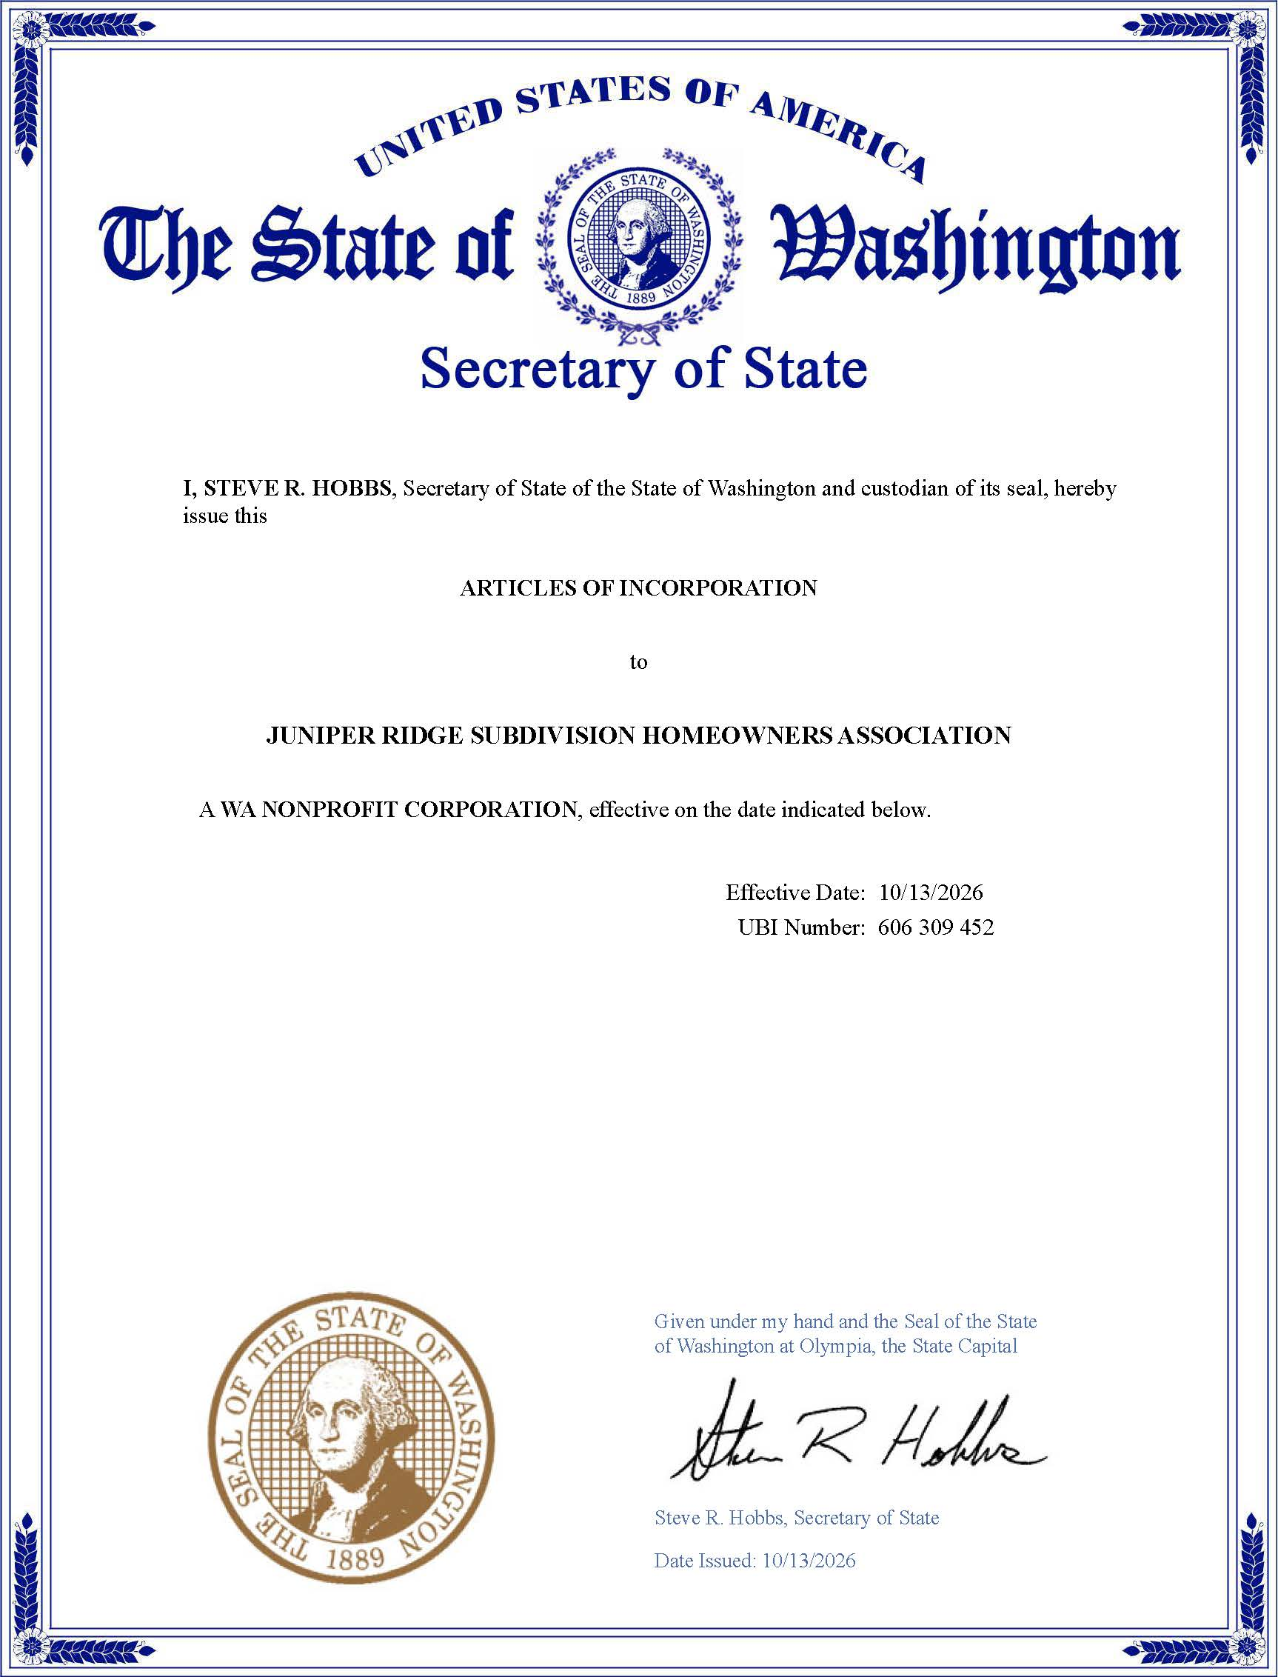

EXHIBIT D
TO PUBLIC OFFERING STATEMENT
(ASSOCIATION BYLAWS)

BYLAWS OF JUNIPER RIDGE SUBDIVISION HOMEOWNER’S ASSOCIATION

Article 1
Definitions
  - Act. “Act,” as referred to in these Bylaws, means the Washington Uniform Common Interest Ownership Act, RCW 64.90 et, seq.
  - Association. “Association” means JUNIPER RIDGE SUBDIVISION HOMEOWNER'S ASSOCIATION, a nonprofit organized and existing under the laws of the State of Washington.
  - Articles of Incorporation. “Articles of Incorporation” means the Articles of Incorporation of the Association.
  - Declaration. The "Declaration" means the Declaration of Covenants, Conditions and Restrictions for Juniper Ridge Subdivision into which these Bylaws are incorporated, as the same may be subsequently amended or supplemented pursuant to the terms thereof.
  - Incorporation by Reference. Except as otherwise provided herein, the terms that are defined in Article 1 of the Declaration are used in these Bylaws as therein defined.

Article 2
Membership

  - Membership. Each Owner of one or more Lots within the Property shall, immediately upon creation of the Association and thereafter during the entire period of such ownership, be a member of the Association. Such membership shall commence, exist and continue simply by virtue of such ownership, shall expire automatically upon termination of such ownership, and need not be confirmed or evidenced by any certificate or acceptance of membership.
  - Membership List. The Secretary shall maintain at the principal Office of the Association a membership list showing the name and address of the Owner of each Lot. The Secretary may accept as satisfactory proof of such ownership a duly executed and acknowledged conveyance, a title insurance policy, or other evidence reasonably acceptable to the Board of Directors.

Article 3
Meetings and Voting

  - Place of Meetings. Meetings of the members of the Association shall be held at such reasonable place convenient to the members as may be designated in the notice of the meeting.
  - Turnover Meeting. Declarant Juniper Ridge, LLC shall call the first meeting of the Owners to organize the Association within ninety (90) days after termination of the Class B membership as provided in Section 3.7, below. Notice of such meeting shall be given to all Owners as provided in Section 3.5. If a quorum of the Owners is present, the Owners shall elect not fewer than the number of directors sufficient to constitute a quorum of the Board of Directors. If the Declarant fails to call the meeting, the meeting may be called and notice given by any Owner or mortgagee of a Lot. The expense of giving notice shall be paid or reimbursed by the Association. In the event of a lack of quorum at such Turnover Meeting, it may be adjourned as provided in Section 3.6. Nothing in this section shall be construed as preventing Declarant from calling the Turnover Meeting prior to such date, or from calling periodic, informal, informational meetings for the Owners.
  - Annual Meeting. The annual meeting of the members for the election of Directors and for the transaction of such other business as may properly come before the meeting shall be held at such reasonable hour and on such reasonable day as may be established by the Board of Directors or, if the Board should fail to designate a date by the first day of April each year, then at 6:30 p.m. on the second Thursday in December. The first annual meeting shall be held within one year of the date of the Turnover Meeting.
  - Special Meetings. A special meeting of the Association may be called at any time by the President or by a majority of the Board of Directors. A special meeting shall be called upon receipt of a written request stating the purpose of the meeting from members having at least ten percent (10%) of the voting rights entitled to be cast at such meeting. Business transacted at a special meeting shall be confined to the purposes stated in the notice of meeting.
  - Notice of Meeting.
    - Written or printed notice stating the place, day and hour of the meeting, the items on the agenda, including the general nature of any proposed amendment to the Declaration or these Bylaws, any budget changes, any proposal to remove a director or officer and, in case of a special meeting, the purpose or purposes for which the meeting is called, shall be delivered not less than ten (10) nor more than thirty (30) days before the date of the meeting. Such notice shall be given either personally, by mail or, to the extent permitted by law, by electronic mail, facsimile or other form of electronic communication acceptable to the Board of Directors, by or at the direction of the President, the Secretary, or the persons calling the meeting, to each member entitled to vote at such meeting, and to all mortgagees who have requested such notice. If mailed, such notices shall be deemed to be delivered when deposited in the United States mail, with postage fully prepaid thereon, addressed to the member at his or her most recent address as it appears on the records of the Association or to the mailing address of his or her Lot.
    - When a meeting is adjourned for thirty (30) days or more, or when a redetermination of the persons entitled to receive notice of the adjourned meeting is required by law, notice of the adjourned meeting shall be given as for an original meeting. In all other cases, no notice of the adjournment or of the business to be transacted at the adjourned meeting need be given other than by announcement at the meeting at which such adjournment is taken.
    - For a period of seven (7) years following recording of the Declaration, notices of meetings (including agendas) shall also be given to Declarant in the same manner as given to unit owners, and Declarant or a representative of Declarant shall be entitled to attend such meetings, unless the Transition Meeting has happened. In that case, the Declarant will only receive notice if they retain unsold units, and will be treated as unit owners.
  - Quorum. At any meeting of the Association, members having at least twenty percent (20%) of the voting rights entitled to be cast at such meeting, present in person or by proxy or absentee ballot, if permitted by the Board of Directors, shall constitute a quorum, except when a larger quorum is required by the Declaration. When a quorum is once present to organize a meeting, it cannot be broken by the subsequent withdrawal of a member or members. If any meeting of members cannot be organized because of a lack of quorum, the members who are present, either in person or by proxy, may adjourn the meeting from time to time not less than forty-eight (48) hours nor more than thirty (30) days from the time the original meeting was called until a quorum is present.
  - Voting Rights. The Association shall have two classes of voting membership:
Class A. Class A members shall be all Owners with the exception of the Class B member and shall be entitled to one vote for each Lot owned. When more than one person holds an interest in any Lot, all such persons shall be members. The vote for such Lot shall be exercised as they among themselves determine, but in no event shall more than one vote be cast with respect to any Lot.
Class B. The Class B member shall be the Declarant and shall be entitled to one vote for each Lot owned by Declarant. The Class B membership shall cease and convert to Class A membership upon the happening of the earliest of any of the following events:
    - Within sixty (60) days after conveyance of seventy-five percent (75%) of the Lots in Juniper Ridge Subdivision to Owners other than a successor Declarant;

    - The expiration of two (2) years after the closing of the sale of the last Lot to an Owner other than a successor Declaration; or

    - At such earlier time as Declarant may elect in writing to terminate Class B membership.
  - Fiduciaries and Joint Owners. An executor, administrator, guardian or trustee may vote or grant consent with respect to any Lot owned or held in such capacity, whether or not the specific right shall have been transferred to his or her name; provided that such person shall satisfy the Secretary that he or she is the executor, administrator, guardian or trustee, holding such Lot in such capacity. Whenever any Lot is owned by two or more persons jointly, according to the records of the Association, the vote of such Lot may be exercised by any one of the Owners, in the absence of protest by a co-owner. In the event of disagreement among the co-Owners, the vote of such Lot shall be disregarded completely in determining the proportion of votes given with respect to such matter, unless a valid court order establishes the authority of a co-owner to vote.
  - Tenants and Contract Vendors. Unless otherwise expressly stated in the rental agreement or lease, all voting rights allocated to a Lot shall be exercised by the Owner. Unless otherwise stated in the contract, all voting rights allocated to a Lot shall be exercised by the vendee of any recorded land sale contract on the Lot.
  - Casting of Votes and Consents. The voting rights or consent of an Owner may be cast in person at a meeting of the Association or, at the discretion of the Board of Directors, by proxy in accordance with paragraph (a) of this Section, by absentee ballot in accordance with paragraph (b) of this Section. by written ballot in accordance with paragraph (c) of this Section, or by any other method specified in the Declaration, these Bylaws or the Act.
    - Proxies. A proxy must be dated and signed by the Owner and is not valid if it is undated or purports to be revocable without notice. Further, such proxy terminates one (1) year after dated unless the proxy specifies a shorter term. The board of directors may not require that a proxy be on a form prescribed by the Board. An Owner may not revoke a proxy given pursuant to this paragraph except by actual notice of revocation to the person presiding over a meeting of the Association or to the Board of Directors if a vote is being conducted by written ballot in lieu of a meeting. A copy of a proxy in compliance with this paragraph provided to the Association by facsimile, electronic mail or other means of electronic communication utilized by the Board of Directors is valid.
    - Absentee Ballots. An absentee ballot, if authorized by the Board of Directors, shall set forth each proposed action and provide Owners an opportunity to vote for or against each proposed action. All solicitations for votes by absentee ballot shall include instructions for delivery of the completed absentee ballot, including the delivery location and instructions about whether the ballot may be canceled if the ballot has been delivered according to the instructions. An absentee ballot shall be counted as an Owner present for the purpose of establishing a quorum. Even if an absentee ballot has been delivered to an Owner, the Owner may vote in person at a meeting if the Owner has returned the absentee ballot and canceled the absentee ballot, if cancellation is permitted in the instructions given under this paragraph.
    - Ballot Meetings. Pursuant to the limitations of RCW 64.90.445(2)(m), and at the discretion of the Board of Directors, any action that may be taken at any annual, regular or special meeting of the Association 's Owners may be taken without a meeting by written ballot to the extent and in the manner provided in RCW 64.90.445 to 64.90.455.
    - Electronic Ballots. To the extent authorized by the Board of Directors and permitted by the Act, any vote, approval or consent of an Owner may be given by electronic ballot.
    - Mortgages. An Owner may pledge or assign such Owner's voting rights to a Mortgagee. In such a case, the Mortgagee or its designated representative shall be entitled to receive all notices to which the Owner is entitled under these Bylaws and to exercise the Owner’s voting rights from and after the time that the Mortgagee shall give written notice of such pledge or assignment to the board of directors. Any first Mortgagee may designate a representative to attend all or any meetings of the Association.
  - Majority Vote. The vote of a majority of the voting rights entitled to be cast by the members present or represented by absentee ballot or proxy, at a meeting at which a quorum is present, shall be necessary for the adoption of any matter voted upon by the members, unless a greater proportion is required by law, by the Declaration, by the Articles of Incorporation, or by these Bylaws.
  - Rules of Order. Unless other rules of order are adopted by resolution of the Association or the Board of Directors, all meetings of the Association shall be conducted according to the latest edition of Robert's Rules of Order, published by Robert's Rules Association.

Article 4
Directors: Management

  - Number and Qualification. The affairs of the Association shall be governed by a Board of Directors of three (3) to five (5) persons. All directors, other than interim directors appointed by Declarant, shall be Owners or co-Owners of Lots. For purposes of this section, the officers of any corporate Owner, the members of any limited liability company and the partners of any partnership shall be considered co-Owners of any Lots owned by such corporation or partnership.
  - Interim Directors. Upon the recording of the Declaration, Declarant shall appoint an interim board of one (1) to three (3) directors, who shall serve until replaced by Declarant or until their successors have been replaced by the Owners as provided herein.
    - Director Turnover Events. Not later than sixty (60) days after conveyance of twenty-five percent (25%) of the units that may be created to Owners other than a Declarant, at least one member and not less than twenty-five percent (25%) of the members of the Board must be elected by Owners other than the Declarant. Not later than sixty (60) days after conveyance of fifty percent (50%) of the units that may be created to Owners other than a Declarant, not less than thirty-three and one-third percent (33.3%) of the members of the board must be elected by Owners other than the Declarant. Until such members are elected and take office, the existing board may continue to act on behalf of the Association.
  - Transitional Advisory Committee. Unless the Turnover Meeting has already been held, Declarant shall call a meeting of the Owners for the purpose of forming a Transitional Advisory Committee. The meeting shall be called within sixty (60) days after the date Declarant conveys fifty percent (50%) or more of the Lots then existing in Juniper Ridge Subdivision to Owners other than a successor Declarant. The committee shall consist of two (2) or more Owners elected by the Owners other than Declarant and not more than one (1) representative of Declarant. The members shall serve until the Turnover Meeting. The Transitional Advisory Committee shall be advisory only and its purpose shall be to enable ease of transition from administrative control of the Association by Declarant to control by the Owners. The committee shall have access to any information, documents and records that Declarant must turn over to the Owners at the time of the Turnover Meeting. If Declarant fails to call the meeting to elect a Transitional Advisory Committee within the time specified, the meeting may be canceled and notice given by any Owner. If the Owners fail to elect a Transitional Advisory Committee at the meeting called for such purpose, Declarant shall have no further obligation to form the committee.
  - Election and Tenure of Office.
    - At the Turnover Meeting, any remaining interim directors shall resign, and the Owners shall elect three (3) directors, two (2) to serve for two (2) years and one (l) to serve for one (1) year. The two nominees receiving the greatest number of votes shall serve for two (2) years. In the event of a tie, term selection shall be randomly selected. Thereafter the successors to each director shall serve for two (2) year terms each.
    - Upon a majority vote of the voting rights entitled to be cast by the members present or represented by absentee ballot or proxy at a meeting or ballot meeting at which a quorum is present, the Board of Directors may be increased from three (3) directors to five (5) directors. At the next annual meeting or a special meeting called for such purpose, two (2) additional directors shall be elected, one (1) to serve for a two-year term and one (l) to serve for a one-year term. Term selection shall be in the same manner as provided in paragraph (a), above.
    - All directors shall hold office until their respective successors are elected by the Owners. Election shall be by the plurality system.
  - Vacancies.
    - A vacancy in the Board of Directors shall exist upon the death, resignation or removal of any director, or if the authorized number of directors is increased, or if the members fail at any annual or special meetings of members at which any director or directors are to be elected to elect the full authorized number of directors to be voted for at that meeting. Vacancies in interim directors shall be filled by Declarant.
    - Vacancies in the Board of Directors, other than interim directors, may be filled by a majority of the remaining directors even though less than a quorum, or by a sole remaining director. Each director so elected shall hold office for the balance of the unexpired term until his or her successor is elected.
  - Removal of Directors. All or any number of directors, other than interim directors, may be removed, with or without cause, at any meeting of members at which a quorum is present, by a vote of a majority of the number of votes entitled to be cast at an election of directors.
No removal of a director shall be effective unless the matter of removal was an item on the agenda and stated in the notice of the meeting as provided in these Bylaws.
  - Powers. The Board of Directors shall have all the powers and duties necessary for the administration of the affairs of the Association, except such powers and duties as by law or by the Declaration or by these Bylaws may not be delegated to the Board of Directors by the Owners. The Board of Directors may delegate responsibilities to committees or a managing agent but shall retain ultimate control and supervision. The powers and duties to be exercised by the Board of Directors shall include, but not be limited to, those set forth in the Declaration and the following:
    - Carry out the program for maintenance, upkeep, repair and replacement of Common Areas and any other property required to be maintained by the Association as described in the Declaration and these Bylaws.
    - Determine the amounts required for operation, maintenance and other affairs of the Association, and the making of such expenditures.
    - Prepare a budget for the Association, and assessment and collection of the Assessments, pursuant to RCW 64.90.525.
    - Employ and dismiss such personnel as may be necessary for such maintenance, upkeep and repair.
    - Employ legal, accounting or other personnel for reasonable compensation to perform such services as may be required for the proper administration or the Association; provided, however, the Board may not incur or commit the Association to incur legal fees in excess of $5,000 for any specific litigation or claim matter or enter into any contingent fee contract on any claim in excess of $100,000 unless the Owners have enacted a resolution authorizing the incurring of such fees by a vote of seventy-five percent (75%) of the voting rights of the Association. These limitations shall not be applicable to legal fees incurred in defending the Association or the Board of Directors from claims or litigation brought against them. The limitations set forth in this paragraph shall increase by ten percent on each fifth (5th) anniversary of the recording of the Declaration. To the extent required by the Act, the Board shall notify the Owners before instituting litigation or administrative proceedings. With regard to any pending litigation involving the Association, the Board shall periodically report to the Owners as to the status (including settlement offers), progress, and method of funding such litigation. Nothing in this paragraph shall be construed as requiring the Board to disclose any privileged communication between the Association and its counsel.
    - Open bank accounts on behalf of the Association and designating the signatories required therefor.
    - Prepare and file, or cause to be prepared and filed, any required income tax returns or forms for the Association.
    - Purchase Lots at foreclosure or other judicial sales in the name of the Association, or its designee.
    - Sell, lease, mortgage, vote the votes appurtenant to (other than for the election of directors), or otherwise deal with Lots acquired by the Association or its designee.
    - Obtain insurance or bonds pursuant to the provisions of these Bylaws and review such insurance coverage at least annually.
    - From time to time adopt, modify, or revoke such rules and regulations governing the details for the operation of the Association, the conduct of persons and the operation and use of the Lots and Common Areas as the Board of Directors may deem necessary or appropriate to ensure the peaceful and orderly use and enjoyment of the Property. Such action may be overruled or modified by vote of not less than seventy-five percent (75%) of the voting rights of each class of members present, in person or by proxy, at any meeting, the notice of which shall have stated that such modification or revocation of rules and regulations will be under consideration.
    - Enforce by legal means the provisions of the Declaration, these Bylaws and any rules and regulations adopted hereunder.
    - In the name of the Association, maintain a current mailing address of the Association, file annual reports with the Washington Secretary of State and maintain and keep current the information required to enable the Association to comply with RCW 64.90.495.
    - Subject to Section 6.8 of the Declaration, enter into management agreements with professional management firms as required by the Declaration or these Bylaws.
  - Meetings.
    - Meetings of the Board of Directors shall be held at such place as may be designated from time to time by the Board of Directors or other persons calling the meeting.
    - Annual meetings of the Board of Directors shall be held within thirty (30) days following the adjournment of the annual meetings of the members.
    - Special meetings of the Board of Directors for any purpose or purposes may be called at any time by the President or by any two directors.
    - Unless other rules of order are adopted by resolution of the Association or the Board of Directors, all meetings of the Board of Directors shall be conducted according to the latest edition of Robert 's Rules of Order, published by Robert's Rules Association.
    - For a period of seven (7) years following recording of the Declaration, notices of meetings (including agendas) shall also be given to Declarant in the same manner as given to directors, and Declarant or a representative of Declarant shall be entitled to attend such meetings. If the Transition Meeting has happened, the Declarant will only be given notices of meetings if they retain unsold units and qualify as a unit owner.
    - Notwithstanding anything which may be contrary herein, all meetings of the Board and/or Association may be conducted via ZOOM.
  - Open Meetings.
    - All meetings of the Board of Directors shall be open to Owners except that, in the discretion of the Board, the following matters may be considered in executive session: (i) consultation with legal counsel concerning the rights and duties of the Association regarding existing or potential litigation, or criminal matters; (ii) personnel matters, including salary negotiations and employee discipline; (iii) negotiation of contracts with third parties; and (iv) collection of unpaid assessments. Except in the case of an emergency, the Board of Directors shall vote in an open meeting whether to meet in executive session. If the Board of Directors votes to meet in executive session, the presiding officer shall state the general nature of the action to be considered, as precisely as possible, when and under what circumstances the deliberations can be disclosed to Owners. The statement, motion or decision to meet in the executive session shall be included in the minutes of the meeting, and any contract or action considered in executive session shall not become effective unless the Board, following the executive session, reconvenes in open meeting and votes on the contract or action, which shall be reasonably identified in the open meeting and included in the minutes.
    - Meetings of the Board of Directors may be conducted by telephonic or by other means of communication that allows all members of the Board participating to hear each other simultaneously or otherwise to be able to communicate during the meeting, except that if a majority of the Lots are principal residences of the occupants, then: (i) for other than emergency meetings, notice of each Board of Directors' meeting shall be posted at a place or places on the property at least three (3) days prior to the meeting, or notice shall be provided by a method otherwise reasonably calculated to inform the Owners of such meeting; and (ii) only emergency meetings of the Board of Directors may be conducted by telephonic communication or such other means. The meeting and notice requirements of this Section may not be circumvented by chance or social meetings or by any other means.
  - Notice of Meetings.
    - Notice of the time and place of meetings shall be given to each director orally, or delivered in writing personally, by mail or to the extent permitted by the Act, by electronic mail, facsimile or other form of electronic communication acceptable to the Board of Directors at least twenty-four (24) hours before the meeting. Notice shall be sufficient if actually received at the required time or if mailed or sent electronically not less than twenty-four (24) hours before the meeting. If mailed, the notice shall be directed to the address shown on the Association’s records or to the director's actual address ascertained by the person giving the notice. Such notice need not be given for an adjourned meeting if such time and place is fixed at the meeting adjourned. For a period of 7 years following recording of the Declaration, notices of meetings (including agendas) shall also be given to Declarant in the same manner as given to the directors, unless the Transition Meeting has happened. In that case, Declarant will only be given notices if they retain unsold units and shall be treated as a regular Unit Owner.
    - Attendance of a director at a meeting shall constitute a waiver of notice of such meeting except when a director attends a meeting for the express purpose of objecting to the transaction of any business because the meeting is not lawfully called or convened.
  - Quorum and Vote.
    - A majority of the directors shall constitute a quorum for the transaction of business. A minority of the directors, in the absence of a quorum, may adjourn from time to time but may not transact any business.
    - The action of a majority of the directors present at any meeting at which there is a quorum shall be the act of the Board of Directors unless a greater number is required by law, the Declaration, the Articles of Incorporation or these Bylaws.
    - A director who is present at a meeting of the Board of Directors at which action is taken on any Association matter is presumed to have assented to the action unless the director votes against the action or abstains from voting on the action because the director claims a conflict of interest. When action is taken on any matter at a meeting of the Board of Directors, the vote or abstention of each director present must be recorded in the minutes of the meeting except that officers may be elected by secret ballot.
  - Liability. Neither a member of the Board of Directors nor an officer of the Association shall be liable to the Association or any Owner or third party for any damage, loss or prejudice suffered or claimed on account of any action or failure to act in the performance of his or her duties, so long as the individual acted in good faith, believed that the conduct was in the best interests of the Association, or at least was not opposed to its best interests, and in the case of criminal proceedings, had no reason to believe the conduct was unlawful. Following election of a new Board as described in Section 4.4(a), in the event any member of the Board of Directors or any officer of the Association is threatened with or made a party to any proceeding because the individual was or is a director or officer of the Association, the Association shall defend such individual against such claims and indemnify such individual against liability and expenses incurred to the maximum extent permitted by law. The managing agent of the Association, and its officers and employees, shall not be liable to the Association, the Owners or any third party on account of any action or failure to act in the performance of its duties as managing agent, except for acts of gross negligence or intentional acts, and the Association shall indemnify the managing agent and its officers and employees from any such claims, other than for gross negligence or intentional misconduct.
  - Compensation. No director shall receive any compensation from the Association for acting as such.
  - Executive Covenants and Other Committees. Subject to law, the provisions of the Declaration and these Bylaws, the Board of Directors, may appoint an Executive Committee, a Covenants Committee to be responsible for covenant enforcement as provided in Section 4.15 and such other standing or temporary committees as may be necessary from time to time consisting of Owners and at least one member of the Board of Directors and having such powers as the Board of Directors may designate. Such committees shall hold office at the pleasure of the Board.
  - Enforcement Procedures. The Association shall have the power, as provided in the Declaration, to impose sanctions for any violation of the Declaration, these Bylaws or the Rules and Regulations. To the extent specifically required by the Declaration, the Board of Directors shall comply with the following procedures prior to the imposition of sanctions:
    - Notice. The Board of Directors or its delegate shall serve the alleged violator with written notice describing (i) the nature of the alleged violation, (ii) the proposed sanction to be imposed, (iii) a statement that the alleged violator shall have fourteen (14) days to present a written request for a hearing before the Board of Directors or a Covenants Committee appointed by the Board of Directors, if any; and (iv) a statement that the proposed sanction may be imposed as contained in the notice unless a hearing is requested within fourteen (14) days of the notice.
    - Response. The alleged violator shall respond to the notice of the alleged violation in writing within such fourteen (14) day period, regardless of whether the alleged violator is challenging the imposition of the proposed sanction. If the alleged violator cures the alleged violation and notifies the Board of Directors in writing within such fourteen (14) day period the Board of Directors may, but shall not be obligated to, waive the sanction. Such waiver shall not constitute a waiver of the right to sanction future violations of the same or other provisions by any person. If a timely request for a hearing is not made, the sanction stated in the notice shall be imposed; provided, however, that the Board of Directors or Covenants Committee may, but shall not be obligated to, suspend any proposed sanction if the violation is cured within the fourteen (14) day period. Any response or request for a hearing shall be delivered to the Association's manager, President or Secretary, or as otherwise specified in the notice of violation. Under no circumstances may the Board of Directors suspend an Owner's right to vote in response to a violation or enforcement action.
    - Proof of Notice. Prior to the effectiveness of sanctions imposed pursuant to this section, proof of proper notice shall be placed in the minutes of the Board of Directors or Covenants Committee, as applicable. Such proof shall be deemed adequate if a copy of the notice, together with a statement of the date and manner of delivery, is entered by the officer, director, or agent who delivered such notice. The notice requirement shall be deemed satisfied if the alleged violator or its representative requests and appears at the hearing.
    - Hearing. If a hearing is requested within the allotted fourteen (14) day period, the hearing shall be held before the Board of Directors or the Covenants Committee, as applicable. The alleged violator shall be afforded a reasonable opportunity to be heard. The minutes of the meeting shall contain a written statement of the results of the hearing (i.e., the decision) and the sanction, if any, to be imposed.
    - Appeal. Following a hearing before the Covenants Committee, if applicable, the violator shall have the right to appeal the decision to the Board of Directors. To exercise this right, the violator must deliver a written notice of appeal to the Association’s manager, President or Secretary within ten (10) days after the hearing date.
    - Enforcement Policies. The Board of Directors, by Resolution, may adopt additional policies and procedures governing enforcement of the Declaration, these Bylaws or the Rules and Regulations.

Article 5
Officers

  - Designation and Qualification. The officers of the Association shall be the President, the Secretary, the Treasurer, and such Vice Presidents and subordinate officers as the Board of Directors shall from time to time appoint. Each officer shall be a member of the Board of Directors. Any two offices, except the offices of President and Secretary, may be held by the same person.
  - Election and Vacancies. The officers of the Association shall be elected annually by the Board of Directors at the organization meeting of each new Board to serve for one (1) year and until their respective successors are elected. If any office shall become vacant by reason of death, resignation, removal, disqualification or any other cause, the Board of Directors shall elect a successor to fill the unexpired term at any meeting of the Board of Directors.
  - Removal and Resignation.
    - Any officer may be removed upon the affirmative vote of a majority of the directors whenever, in their judgment, the best interests of the Association will be served thereby. The removal of an officer shall be without prejudice to the contract rights, if any, of the officer so removed.
    - Any officer may resign at any time by giving written notice to the Board of Directors, the President or the Secretary of the Association. Any such resignation shall take effect upon receipt of such notice or at any later time specified therein. Unless otherwise specified therein, the acceptance of such resignation shall not be necessary to make it effective, provided, however, that the Board of Directors may reject any postdated resignation by notice in writing to the resigning officer. The effectiveness of such resignation shall not prejudice the contract rights, if any, of the Association against the officer resigning.
  - President. The President shall be the chief executive officer of the Association and shall, subject to the control of the Board of Directors, have powers of general supervision, direction and control of the business and affairs of the Association. He or she shall preside at all meetings of the members and of the Board of Directors. He or she shall be an ex officio member of all the standing committees, including the executive committee, if any, shall have the general powers and duties of management usually vested in the office of president of a nonprofit corporation, and shall have such other powers and duties as may be prescribed by the Board of Directors or these Bylaws.
  - Vice Presidents. The Vice Presidents, if any, shall perform such duties as the Board of Directors shall prescribe. In the absence or disability of the President, the President's duties and powers shall be performed and exercised by the Senior Vice President as designated by the Board of Directors.
  - Secretary.
    - The Secretary shall keep or cause to be kept a book of minutes of all meetings of directors and members showing the time and place of the meeting, whether it was regular or special, and if special, how authorized, the notice given, the names of those present at directors' meetings, the number of memberships present or represented at members' meetings and the proceedings thereof.
    - The Secretary shall give or cause to be given such notice of the meetings of the members and of the Board of Directors as is required by these Bylaws or by law. The Secretary shall keep the seal of the Association, if any, and affix it to all documents requiring a seal, and shall have such other powers and perform such other duties as may be prescribed by the Board of Directors or these Bylaws.
    - If there are no Vice Presidents, then in the absence or disability of the President, the President's duties and powers shall be performed and exercised by the Secretary.
  - Treasurer. The Treasurer shall keep and maintain, or cause to be kept and maintained, adequate and correct accounts of the properties and business transactions of the Association, including accounts of its assets, liabilities, receipts and disbursements. The books of accounts shall at all reasonable times be open to inspection by any director. The Treasurer shall deposit or cause to be deposited all moneys and other valuables in the name and to the credit of the Association with such depositories as may be designated by the Board. The Treasurer shall disburse or cause to be disbursed the funds of the Association as may be ordered by the Board, shall render to the President and directors, whenever they request it, an account of all of the Treasurer's transactions as Treasurer and of the financial condition of the Association, and shall have such other powers and perform such other duties as may be prescribed by the Board or these Bylaws.
  - Compensation of Officers. No officer who is a member of the Board of Directors shall receive any compensation from the Association for acting as an officer, unless such compensation is authorized by a resolution duly adopted by the members. The Board of Directors may fix any compensation to be paid to other officers.

Article 6
Assessments, Records and Reports

  - Assessments. As provided in the Declaration, the Association, through its Board of Directors, shall do the following:
    - Assess and collect from every Owner Assessments in the manner described in the Declaration.
    - Keep all funds received by the Association as Assessments, other than reserves described in the Declaration, in the Operations Fund and keep all reserves collected pursuant to the Declaration in the Reserve Fund and use such funds only for the purposes described in the Declaration. All assessments shall be deposited in the name of the Association in a separate federally insured account at a Qualified Financial Institution as defined in RCW 64.90.010 and dictated under 64.90.530. All expenses of the Association shall be paid from the Association's bank account.
    - From time to time, and at least annually, prepare a budget for the Association, estimating the common expenses expected to be incurred with adequate allowance for reserves based upon the reserve study required by the Declaration, and determine whether the Annual Assessment should be increased or decreased. Within thirty (30) days after adopting a proposed annual budget, the Board of Directors shall provide a summary of the budget to all Owners. If the Board of Directors fails to adopt a budget, the last adopted annual budget shall continue in effect.
    - Fix the amount of the Annual Assessment against each Lot at least thirty (30) days in advance of each Annual Assessment period. Written notice of any Assessment shall be sent to every Owner subject thereto and to any first mortgagee requesting such notice. The due dates shall be established by the Board of Directors, which may fix a regular flat Assessment payable on a monthly, quarterly, semiannual or annual basis. The Board of Directors shall cause a roster of the Lots to be prepared showing Assessments applicable to each Lot. The roster shall be kept in the Association office and shall be subject to inspection by any Owner or mortgagee during regular business hours. Within ten (10) business days after receiving a written request, and for a reasonable charge, the Association shall furnish to any Owner or mortgagee a recordable certificate setting forth the unpaid Assessments against such Owner's Lot. Such certificate shall be binding upon the Association, the Board of Directors, and every Owner as to the amounts of unpaid Assessments.
    - Enforce the Assessments in the manner provided in the Declaration.
    - Keep records of the receipts and expenditures affecting the Operations Fund and Reserve Fund and make the same available for examination by members and their mortgagees at convenient hours, maintain an Assessment roll showing the amount of each Assessment against each Owner, the amounts paid upon the account and the balance due on the Assessments, give each member written notice of each Assessment at least thirty (30) days before the time when such Assessments shall become due and payable; and for a reasonable charge, promptly provide any Owner or mortgagee who makes a request in writing with a written certificate of such Owner's unpaid Assessments.
  - Records. The Association shall keep within the State of Washington correct and complete financial records sufficiently detailed for proper accounting purposes, keep minutes of the proceedings of its members, Board of Directors and committees having any of the authority of the Board of Directors, and retain all documents, information and records turned over to the Association by Declarant. All documents, information and records delivered to the Association by Declarant pursuant to RCW 64.90.420 and other records of the Association shall be kept within the State of Washington in the manner and for the time periods specified in RCW 64.90.420.
  - Statement of Assessments Due. The Association shall provide, within ten (10) business days after receipt of a written request from an Owner, a written statement that provides: (a) the amount of assessments due from the Owner and unpaid at the time the request was received, including regular and special assessments, fines all other charges, accrued interest, and late payment charges; (b) the percentage rate at which interest accrues on assessments that are not paid when due; and (c) the percentage rate used to calculate the charges for late payment or the amount of a fixed-rate charge for late payment. The Association is not required to comply with this section if the Association has commenced litigation by filing a complaint against the Owner and the litigation is pending when the statement would otherwise be due.
  - Inspection of Books and Records. Except as otherwise provided in RCW 64.90.495, during normal business hours or under other reasonable circumstances, the Association shall make reasonably available for examination and, upon written request, available for duplication, by Owners, lenders, and holders of any mortgage of a Lot that make the request in good faith for a proper purpose, current copies of the Declaration, Articles, Bylaws, Rules and Regulations, amendments or supplements to such documents and the books, records, financial statements and current operating budget of the Association. The Association shall maintain a copy, suitable for purposes of duplication, of each of the following: (a) the Declaration, these Bylaws, the Rules and Regulations and any amendments or supplements to them, (b) the most recent financial statement of the Association, and (c) the current operating budget of the Association. The Association, within ten (10) business days after receipt of a written request by an Owner, shall furnish copies of such documents to the requesting Owner. Upon written request, the Association shall make such documents, information and records available to such persons for duplication during reasonable hours. The Board of Directors, by resolution, may adopt reasonable rules governing the frequency, time, location, notice and manner of examination and duplication of Association records and the imposition of a reasonable fee for furnishing copies of such documents, information or records. The fee may include reasonable personnel costs for furnishing the documents, information or records.
  - Execution of Documents. The Board of Directors may, except as otherwise provided in the Declaration, Articles of Incorporation or these Bylaws, authorize any officer or agent to enter into any contract or execute any instrument in the name of and on behalf of the Association. Such authority may be general or confined to specific instances. Unless so authorized by the Board of Directors, no officer, agent or employee shall have any power or authority to bind the Association by any contract or engagement, to pledge its credit, or to render it liable for any purpose or for any amount.
  - Reports and Audits. An annual financial statement consisting of a balance sheet and an income and expense statement for the preceding year shall be rendered by the Board of Directors to all Owners and to all mortgagees who have requested the same within ninety (90) days after the end of each fiscal year. If the Annual Assessments exceed $50,000 for the year, then the Board of Directors shall cause such financial statements to be reviewed within ninety (90) days after the end of the fiscal year by an independent certified public accountant licensed in Washington. If the Annual Assessments are less than $50,000, an annual audit is required but may be waived annually by the Owners, other than the Declarant, of Lots to which a majority of the votes in the Association are allocated, excluding the votes allocated to the Declarant pursuant to Section 3.7, above. From time to time, the Board of Directors, at the expense of the Association, may obtain an audit of the books and records pertaining to the Association and furnish copies thereof to the members. At any time any Owner or holder of a mortgage may, at their own expense, cause an audit or inspection to be made of the books and records of the Association. This follows the laws of the State of Washington and can be adjusted if the laws change.

Article 7
Insurance

  - Types of Insurance. For the benefit of the Association and the Owners, the Board of Directors shall obtain and maintain at all times, and shall pay for out of the Operations Fund, the types of insurance described in the following sections of this Article 7.
  - Liability Insurance. The Association shall maintain comprehensive general liability insurance coverage insuring the Declarant, the Association, the Board of Directors, and the managing agent, against liability to the public or to Owners and their invitees or tenants, incident to the operation, maintenance, ownership or use of the Property, including legal liability arising out of lawsuits related to employment contracts of the Association. There may be excluded from such policy or policies coverage of an Owner (other than as a member of the Association or Board of Directors) for liability arising out of acts or omissions of such Owner and liability incident to the ownership and/or use of the part of the Property as to which such Owner has the exclusive use or occupancy.
    - Limits of liability under such insurance shall not be less than One Million Dollars ($1,000,000) on a combined single-limit basis,
    - Such policy or policies shall be issued on a comprehensive liability basis and shall provide a cross-liability endorsement wherein the rights of named insureds under the policy or policies shall not be prejudiced as respects his, her or their action against another named insured.
  - Property Damage Insurance.
    - Common Areas. The Association shall obtain, and maintain in effect, fire and extended coverage casualty insurance (including coverage for damage resulting from vandalism and malicious mischief) with respect to the Common Areas (including any insurable improvements in the Common Areas) in an amount equal to 100% of the replacement cost thereof.
      - The casualty coverage may be obtained on a “blanket” basis.
      - The casualty insurance shall include the following terms, if the Board determines they are reasonably available:
        - A waiver of subrogation by the insurer as to any claims against the Board, any Owner, or any guest of an Owner;
        - A waiver by the insurer of its right to repair and reconstruct instead of paying cash;
        - A provision that no policy may be canceled, invalidated, or suspended because of the action of an Owner;
        - A provision that no policy may be canceled, invalidated, or suspended because of the conduct of any director, officer, or employee of the Association unless the insurer gives the Association a prior written demand that the Association correct the defect and allows the Association a reasonable time to make the correction; and
        - A provision that any “other insurance” clause in any policy shall exclude from its coverage all owners’ policies.
    - Units with Shared Boundaries. Not applicable.
  - Workers’ Compensation Insurance. The Association shall maintain workers' compensation insurance to the extent necessary to comply with any applicable laws.
  - Fidelity Insurance.
    - The Board of Directors may cause the Association to maintain blanket fidelity insurance for all officers, directors, trustees and employees of the Association and all other persons handling or responsible for funds of, or administered by, the Association. In the event that the Association has retained a management agent, the Board of Directors may require such agent to maintain fidelity insurance for its officers, employees and agents handling or responsible for funds of, or administered on behalf of, the Association. The cost of such insurance, if any, may be borne by the Association.
    - The total amount of fidelity coverage required shall be based upon the best business judgment of the Board of Directors.
    - Such fidelity insurance shall name the Association as obligee and shall contain waivers by the issuers of the insurance of all defenses based upon the exclusion of persons serving without compensation from the definition of "employees" or similar terms or expressions. The insurance shall provide that it may not be canceled or substantially modified (including cancellation for nonpayment of premium) without at least ten (10) days' prior written notice to the Association.
  - Insurance by Attached and/or Detached, Single Family Unit Owners. Each Owner of a Lot with a single family, attached and/or detached residence, at his or her own expense, shall obtain homeowner's insurance covering the structure on the Owner's Lot and liability resulting from use or ownership of the Lot. Each Owner under this section shall be responsible for obtaining, at his or her own expense, homeowner's insurance covering the improvements on the Owner's Lot and liability resulting from use or ownership of the Lot. The insurance coverage maintained by the Association shall not be brought into contribution with the insurance obtained under this section by the Owners of detached, single-family Lots.
  - Planned Community Act Requirements. The insurance maintained by the Association shall comply with the requirements of the Act enumerated in RCW 64.90.470.

Article 8
General Provisions

  - Waiver of Notice. Whenever any notice to any member or director is required by the Act or other law, the Declaration, the Articles of Incorporation, or these Bylaws, a waiver of notice in writing signed at any time by the person entitled to notice shall be equivalent to the giving of the notice.
  - Action Without Meeting. Any action that the Act, the Declaration, the Articles of Incorporation or the Bylaws require or permit the members or directors to take at any meeting may be taken without a meeting or ballot meeting if a consent in writing setting forth the action so taken is signed by all of the members or those members entitled to vote on the matter. The consent, which shall have the same effect as a unanimous vote of the members or directors, shall be filed in the records of minutes of the Association.
  - Conflicts. These Bylaws are intended to comply with the Act, the Washington Nonprofit Corporation Law, the Declaration and the Articles of Incorporation. In case of any irreconcilable conflict, such statutes and documents shall control over these Bylaws.

Article 9
Amendments To Bylaws

  - How Proposed. Amendments to these Bylaws shall be proposed by the Board of Directors or by members holding at least thirty percent (30%) of the voting rights entitled to be cast for such amendment. The proposed amendment must be reduced to writing and shall be included in the notice of any meeting at which action is to be taken thereon or be attached to any request for consent to the amendment.
  - Adoption.
    - A resolution adopting a proposed amendment may be proposed by either the Board of Directors or by the members and may be approved by the membership at a meeting called for such purpose or by written consent of the members. Members not present at the meeting considering such amendment may express their approval in writing or by proxy. Any resolution must be approved by members holding a majority of the voting rights, together with the written consent of the Class B member, if any. Amendment or repeal of any provision of these Bylaws that is also contained in the Declaration must be approved by the same voting requirement for amendment of such provision of the Declaration.
    - Notwithstanding the provisions of the preceding paragraph, until the Turnover Meeting has occurred, Declarant shall have the right to amend these Bylaws in order to comply with the requirements of the Federal Housing Administration, the United States Department of Veterans Affairs, the Fanners Home Administration of the United States, the Federal National Mortgage Association, the Government National Mortgage Association, the Federal Home Mortgage Loan Corporation, any department, bureau, board, commission or agency of the United States or the State of Washington, or any corporation wholly owned, directly or indirectly, by the United States or the State of Washington that insures, guarantees or provides financing for a planned community or lots in a planned community. After the Turnover Meeting, any such amendment shall require the approval of a majority of the voting rights of the Association, voting in person, by proxy or by ballot, at a meeting or ballot meeting of the Association at which a quorum is represented.
  - Relationship to Declaration. If a provision required to be in the Declaration under Washington law is included in these Bylaws, the voting requirements for amending the Declaration shall also govern the amendment of the provision in the Bylaws.
  - Execution and Recording. An amendment shall not be effective until certified by the President and Secretary of the Association as being adopted in accordance with these Bylaws and Washington law, acknowledged and recorded in the Deed Records of Clark County, Washington.

Adopted on ____________________________, by the Board of Directors.
Juniper Ridge, LLC
By: ______________________
Its: ______________________
Secretary

EXHIBIT E
TO PUBLIC OFFERING STATEMENT
(CONSTRUCTION RULES & REGULATIONS)

JUNIPER RIDGE SUBDIVISION RULES AND REGULATIONS DURING HOME CONSTRUCTION
  - Pre-Construction Requirements.
    - Architectural Review. Submit site plans, material samples, color swatches and design specs to the Architectural Review Committee (ARC).
    - Local Permits. Pull county and city building codes first, though the HOA can enforce stricter aesthetic rules.
  - Project Timeline and Living Restrictions.
    - Build Time. Homes shall be completed within 12 months from the start of construction. The fencing, sidewalks, pre-planting (including required trees) and wall installation need to be completed within 18 months of Lot purchase if home construction has not started.
    - Temporary Living. Temporary living is not allowed within the Juniper Ridge Subdivision.
  - On-Site Operations and Environmental Controls.
    - Construction Hours. Working hours are Monday through Saturday, 7:00am to 10:00pm, as a means of preserving the peaceful repose of the city residents.
    - Construction Site and Street. Each Lot Owner is responsible for keeping their construction site and the street clean and free of any obstructions.
    - Posting Site Address. Each Lot Owner is responsible for posting their Lot number and address so that it is visible from the street through the duration of construction.
    - Safety. Each Lot Owner is responsible for safety of any persons within their construction project.
    - Erosion Control. Each Lot Owner is responsible for installing and maintaining their erosion control practices through the duration of construction. They are responsible for cleaning any dirt that is tracked into the roadway or into the stormwater system. Cleanup for any erosion onto the roadway or storm system will be completed promptly by the Lot Owner, otherwise they will be subject to fines and/or penalties.
    - Maintenance of Lots During Construction. Each Lot Owner will be responsible for maintaining their Lot in a neat and clean manner prior to and during construction. Owners shall trim or mow grass regularly to prevent unsightly conditions or a fire hazard. Grass shall be trimmed or mowed to no more than 6 inches in height.
    - Common Area and Right of Way. Each Lot Owner shall be responsible for any and all damage that occurs to any common areas or right of ways related to their construction process. Costs of any damage will be charged to the party responsible.
  - Waste Management and Sanitation.
    - Trash/Construction Debris. Each Lot Owner is responsible for removing and legally disposing of any trash, debris and excess materials. Each Lot Owner is also responsible for their own trash bin/dumpster; all trash is to be stored in aforementioned designated trash bin/dumpster. All containers, pallets or other delivery material shall be removed promptly from the site once the material has been installed.
    - Outhouse Requirements. Each Lot is required to provide their own outhouse and/or shared access approved by the HOA through the duration of construction.
  - Material Storage and Street Maintenance.
    - Traffic Flow. Each Lot Owner is responsible to keep the street open to traffic at all times unless approved by the HOA.
    - Storing Construction Materials. All construction material must be stored on the respective Lot. No construction materials shall be stored on public streets or in common areas.
  - Construction Requirements and Responsibilities.
    - Fencing. Each Lot Owner is responsible for the installation of the fencing on the front, back and lower side of their Lot. If the Lot Owner does not share an upper fence with another lot, they are responsible for the cost of installation of said fence. Fence installation must be installed according to the requirements specified on Exhibit #2. All Lot Owners shall install the rail section of the fence facing the interior of their Lot.
    - Retaining Wall Installation. Each Lot Owner is responsible for materials and installation of the retaining wall on the uphill side of their Lot. Post sleeves must be installed during the wall build. Installation must be according to the requirements specified on Exhibit #1.
    - Differences in Start of Construction. If the adjoining Lot is owned by the Declarant, or the adjoining Lot Owners cannot decide on the wall and fence installation start time, the Declarant has the right to have the Lot Owners come to an agreement on start time or installation cost reimbursement.
    - Tree Requirements. Each Lot Owner is responsible for planting and maintaining trees per the Final Landscape Plan (see Exhibit #3).
    - Landscape Requirements. Each Lot is required to have an automatic, underground irrigation system designed with water conservation in mind, to water their front yard landscaping (including the planter strip and trees), unless pre-approved by the Association. Landscaping is to have 75% coverage of lawn and 25% coverage of shrubs, trees, bark dust or decorative rock, and/or is allowed or approved by the Association.
    - Concrete Driveways, Sidewalks and Approaches. Each Lot Owner is responsible for the sidewalks and approaches within their Lot lines. Driveways shall not be within 5 feet of the property line. Per City of La Center Approved Variance - Detached single family homes with a Lot width of 35 feet shall have a driveway maximum width of 18 feet. Detached single family homes with a Lot width of 40 feet shall have a driveway maximum width of 19 feet. Attached (townhome) single family homes shall have a driveway maximum width of 10 feet. Planter strips will be required to be grass and/or low ground cover plants approved by the ARC. Lot Owners are to refer to the City of La Center building requirements for concrete driveways, sidewalks and approaches (see Exhibit #4).

These rules and regulations are in addition to the Juniper Ridge Subdivision CC&R’s and the Rules and Regulations of the City of La Center and Washington state.

City of La Center MDR-16 Code Link:
https://ecode360.com/46860689?highlight=16&highlight=mdr&searchId=11443230914086098#46860689

EXHIBIT #1: LANDSCAPE & RETAINING WALL SPECIFICATIONS
  - Purpose and Scope. This document outlines the mandatory design, material and construction standards for all landscape walls (including retaining walls, garden walls, and decorative planters) within the Juniper Ridge Subdivision community. All projects must receive written approval from the Architectural Review Committee (ARC) before any excavation or construction begins.
  - Submittal Requirements. Prior to approval, the Owner or their licenses contractor must submit an Architectural change Request form accompanied by:
    - Property Plot Plan. A survey or site plan showing the exact location of the proposed wall, including distances to property lines, existing structures, and easements.
    - Design Drawings. A sketch or construction plan showing the wall’s length, height, thickness and method of reinforcement.
    - Material Samples. Photos or physical samples of the proposed wall material, capping, and color palette.
    - Contractor Information. Proof of the contractor’s valid license and insurance (general liability and workers’ compensation) (if applicable).
  - Dimensional Standards.
    - Maximum Wall Length. Variable.
    - Maximum Wall Height. Not to exceed 3 feet 10 inches (46 inches) from the base, (Maximum 3’ or 36” above Finished Grade) completely adhering to the manufacturer’s recommendations unless approved by the ARC. All walls must meet manufacturer specifications and may require Geogrid.
  - Material and Aesthetic Flexibility. To ensure architectural harmony while accommodating site-specific aesthetics, the proposed retaining wall will utilize the premium Allan Block ® System, using Stones of the AB Collection.
    - Block Style Options. Allan Block ® Stones of the AB Collection.
    - Approved Color Profile Selection. Allan Block Classic Grey.
    - Dimensions Per Unit. 8 inches height by 12 inches depth by 18 inches length.
  - Sub-Grade Engineering & Drainage Details.
    - Foundation Trench. Dig the base trench 18 inches wide (460 millimeters) and 4 inches deep (100 millimeters) plus additional to account for the amount of buried block needed per manufacturer spec.
    - Base Foundation. Place a minimum of 6 inches (150 millimeters) of wall rock in the base trench and rake smooth.
    - Water Management. A 4-inch perforated drainpipe nestled in the base, backfilled with a 12-inch-wide column of washed drain rock behind the blocks to allow natural drainage.
    - Soil Separation. Wrapped completely in professional geotextile fabric to keep native silt from clogging the drainage gravel or leaking through the wall face.
    - Link. See Allan Block Residential Landscape Retaining Wall Guide for Installation Requirements. https://allanblock.com/PDF/AB_Residential_Retaining_Walls.pdf

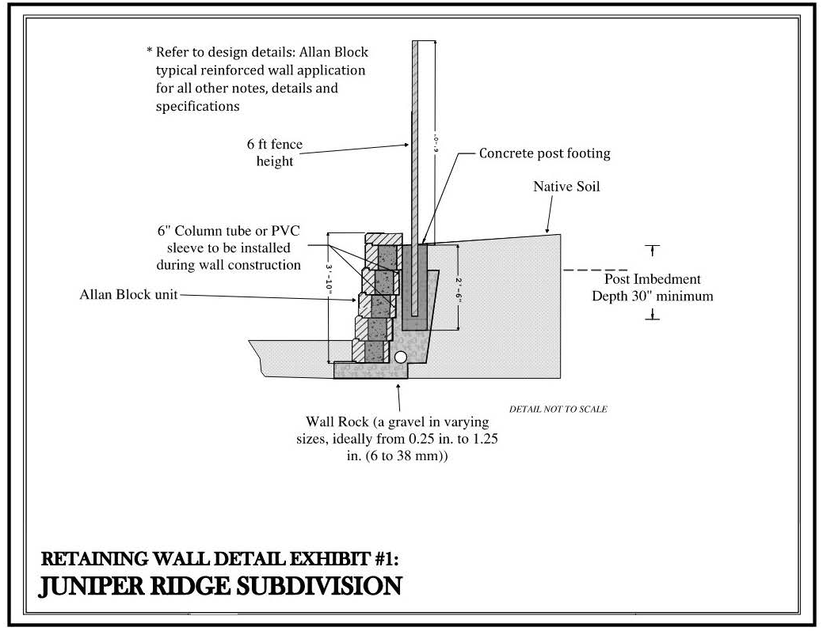

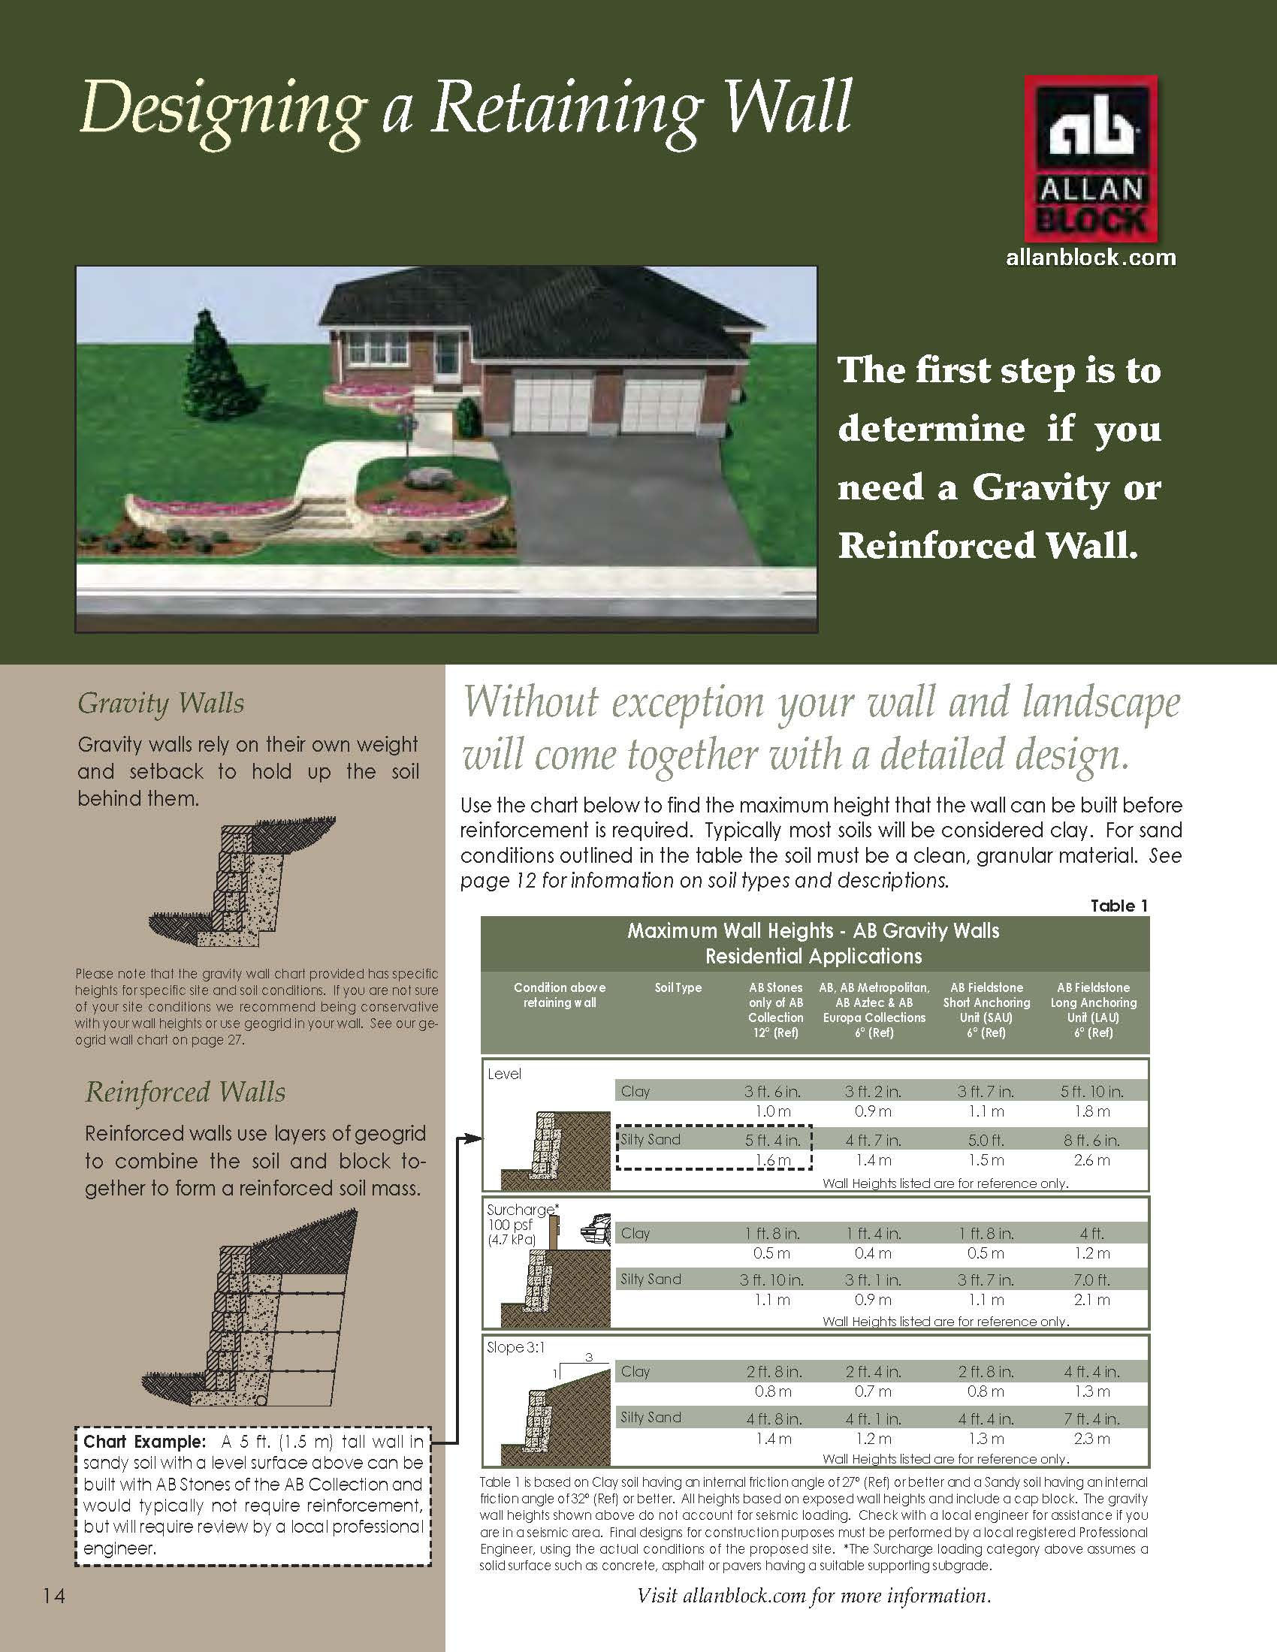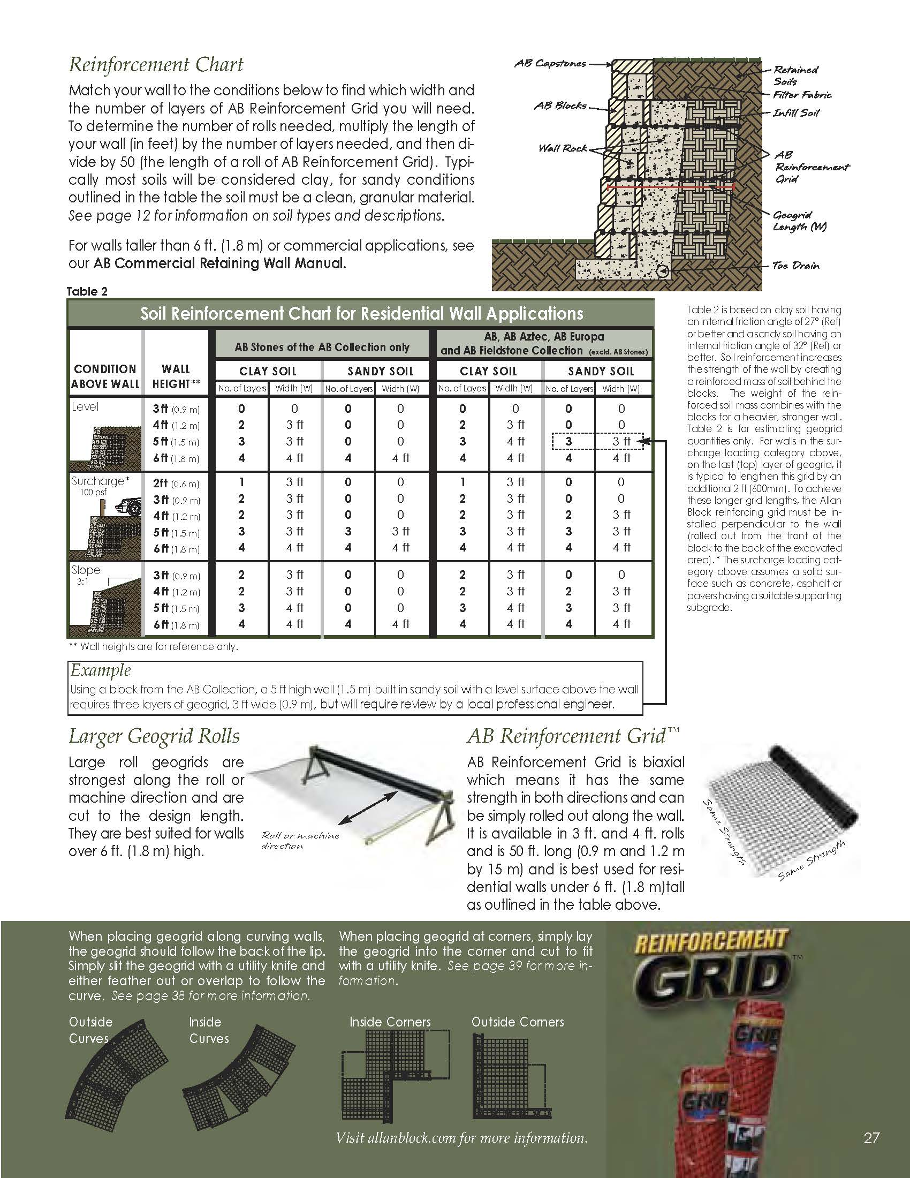

EXHIBIT #2: CEDAR FENCING
  - Purpose and Scope. This document outlines the mandatory design, material and construction standards for all fencing within the Juniper Ridge Subdivision community. All projects must receive written approval from the Architectural Review Committee (ARC) before any excavation or construction begins.
  - Submittal Requirements. Prior to approval, the Owner or their licenses contractor must submit an Architectural change Request form accompanied by:
    - Property Plot Plan. A survey or site plan showing the exact location of the proposed fence(s), including distances to property lines, existing structures, and easements.
    - Design Drawings. A sketch or construction plan showing the fence’s length, height, thickness and method of reinforcement.
    - Material Samples. Photos or physical samples of the proposed fence material and color palette.
    - Contractor Information. Proof of the contractor’s valid license and insurance (general liability and workers’ compensation) (if applicable).
  - Material and Aesthetic Flexibility. To ensure architectural harmony while accommodating site-specific aesthetics, the proposed fencing will feature the following restrictions:
    - Fencing Material Options.
      - 1” by 6” x 6’ #2 No Hole Flat Top Western Red Cedar Slats
      - 2” by 6” Cedar Top Cap & 1” by 4” Side Cap
      - 2” by 4” Fir Rails
      - 1-5/8” Minimum Metal Posts
    - Approved Color Profile Selection.
      - Cedar Natural Tone Semi-Transparent Exterior Stain.
    - Orientation.
      - The rail section of the fence must be installed facing the interior of each lot. Any fencing adjoining greenspace may seek a variance from the ACC for fence type and height but there will be no guaranteed approval.
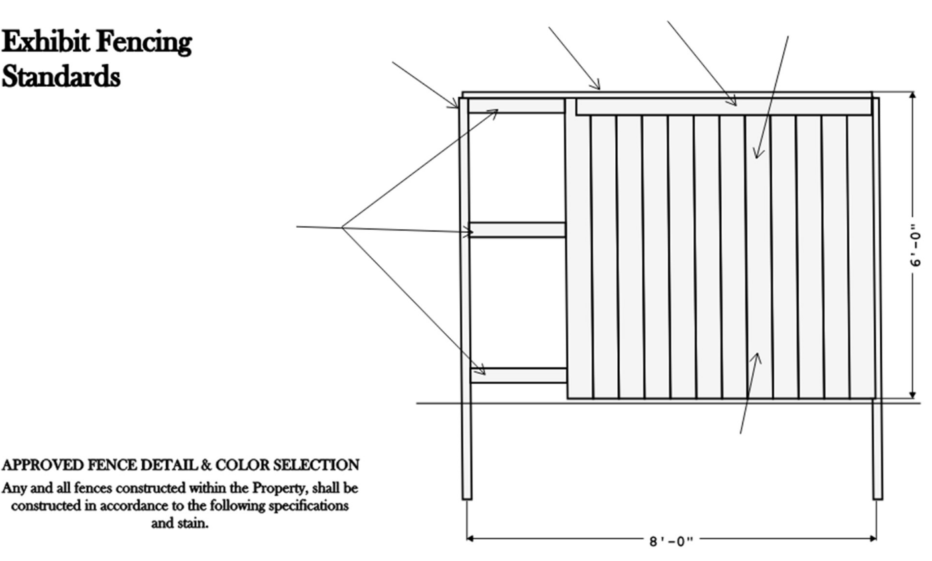
2X6 CEDAR
1X4 CEDAR
1X6 CEDAR SLATS
1 5/8” MINIMUM METAL POSTS
2X4 FIR RAILS
FENCE TO BE STAINED WITH CEDAR NATURAL TONE SEMI-TRANSPARENT STAIN

EXHIBIT #3: FINAL LANDSCAPE PLAN
[Lot Owner is responsible for planting any trees on their respective Lot in the Landscape Plan.]
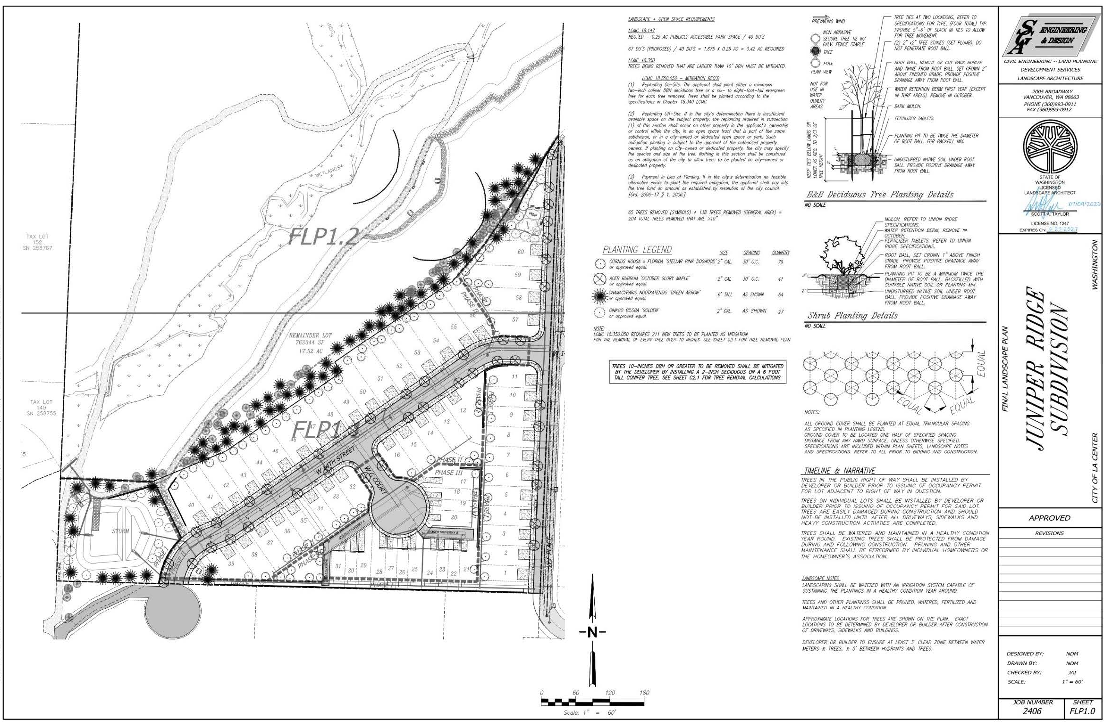
DRAFT

EXHIBIT #4: CONCRETE DETAILS

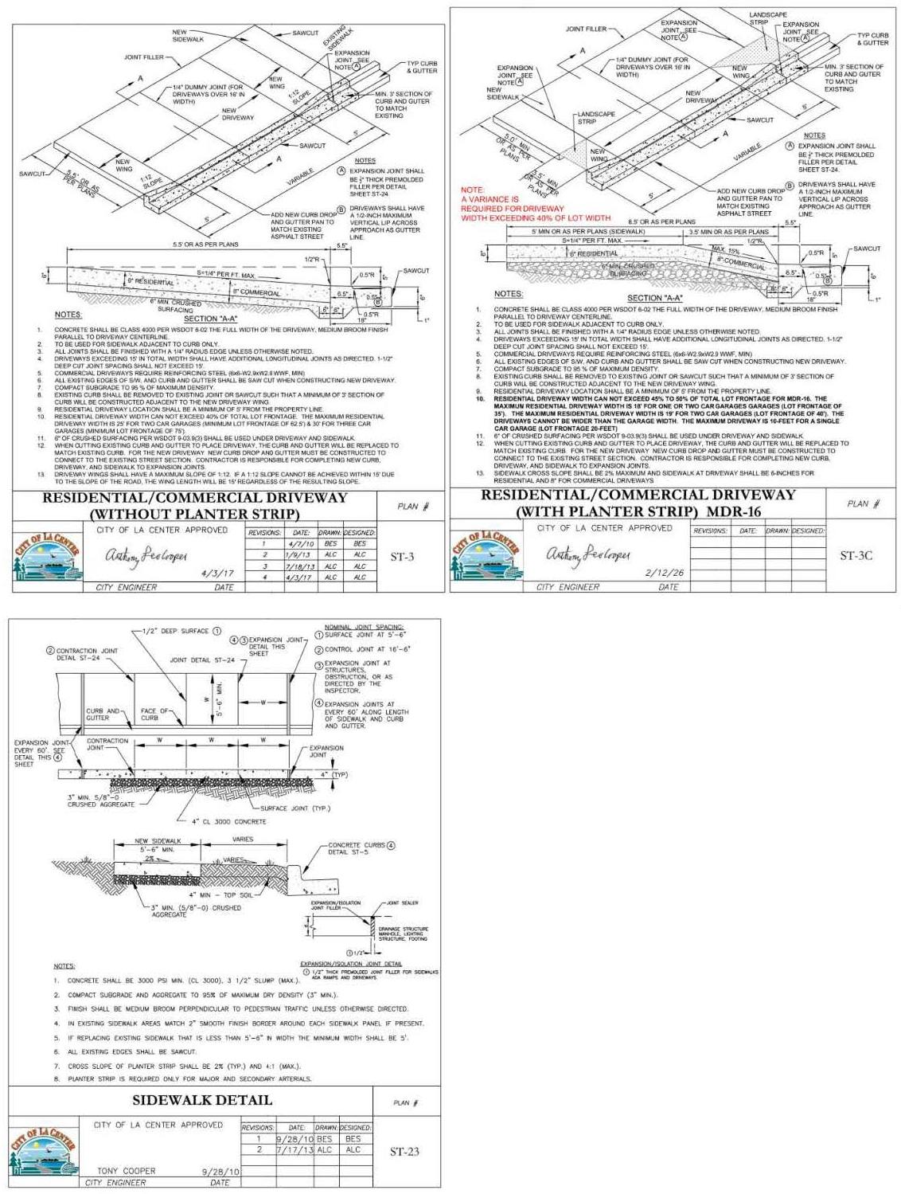
RESIDENTIAL DRIVEWAY LOT CAN NOT EXCEED 40% OF TOTAL LOT FRONTAGE FOR MDR-16. THE MAXIMUM RESIDENTIAL DRIVEWAY WIDTH IS 10’ FOR AN ATTACHED SINGLE-FAMILY HOME (LOT FRONTAGE OF 20’). THE MAXIMUM RESIDENTIAL DRIVEWAY WIDTH IS 18’ FOR A DETACHED SINGLE-FAMILY HOME (LOT FRONTAGE OF 35’). THE MAXIMUM RESIDENTIAL DRIVEWAY IS 19’ FOR A DETACHED SINGLE FAMILY HOME (LOT FRONTAGE OF 40’).

NOTE:
A VARIANCE WAS
APPROVED FOR A MAXIMUM WIDTH OF 40% OF TOTAL LOT FRONTAGE.

EXHIBIT F
TO PUBLIC OFFERING STATEMENT
(ASSOCIATION BUDGET)

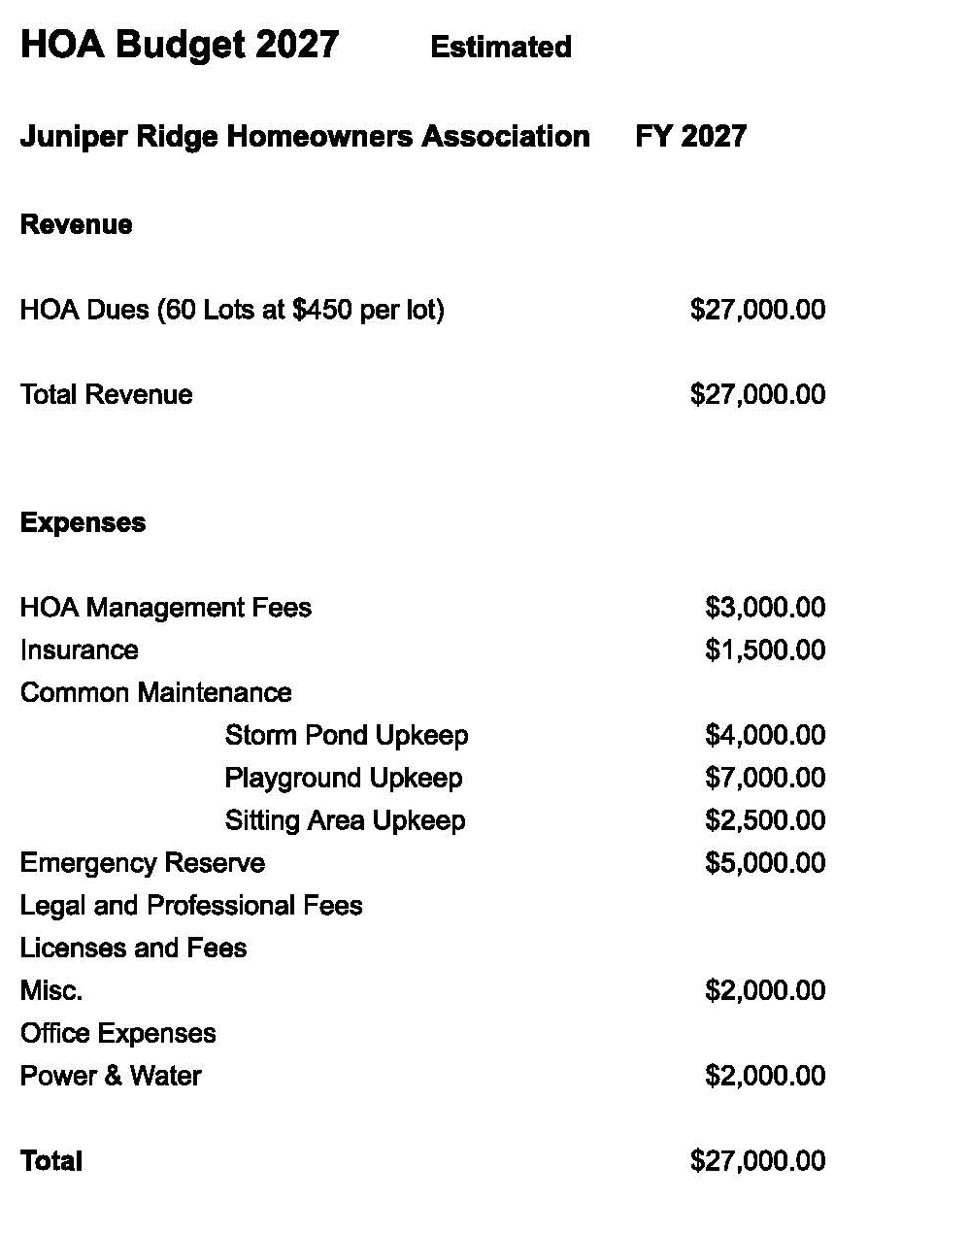

EXHIBIT G
TO PUBLIC OFFERING STATEMENT
(RESERVE STUDY)

NOT APPLICABLE AT THIS TIME

